**Six Weeks Industrial Training Project Report**

On

**Typing Guru (A Typing Tutor)**

Submitted in the Partial fulfillment of the requirement for the Award of Degree of

**Bachelor of Technology**

**In**

**INFORMANTION TECHNOLOGY**

**Batch**

**2017-2021**



**Submitted to**

Er. Vinod Sharma (HOD)

Department of CSE & IT

**Submitted by**

Abdhesh Nayak

B.Tech IT 5th Sem (1701448)

**ACKNOWLEDGEMENT**

A study or a project of this volume can never be the outcome of a single person or just a mere group of dedicated students, so we express our profound sense of gratitude to those who extended their whole hearted help and support to us in completing our project because successful completion of any work requires guidance and help from a number of people .Firstly, it gives us immense pleasure to acknowledge our institute **AMRITSAR COLLEGE OF ENGINEERING AND TECHNOLOGY** for providing us an opportunity in developing a project on “**Typing Guru**”.

It would not have been possible to see through the undertaken project without the guidance of **Udemy Online Course.** It was purely on the basis of their experience and knowledge that we able to clear all the theoretical and technical hurdles during the development phases of this project work.

**Index**

|  |  |  |
| --- | --- | --- |
| **S.N.** | **Contents** | **Page Number** |
| 1 | **Training Objective** | 1 |
| 2 | **Organization Profile** | 2 |
| 3 | **Introduction of training course** | 3-4 |
| 4 | **Introduction to the Project** | 4-6 |
| 5 | **Syllabus Contains of this Course** | 6-7 |
| 6 | **Source Code** | 8 |
| 7 | **Snapshots** | 9-99 |
|  |  |  |

**Training Objective**

An immediate objective of training is to give employees the skill they need to become better workers, resulting in financial gain. Other objectives include creating a supportive workplace. So employees know they are valued and feel more satisfaction in their jobs. Today all organizations are looking for those graduate /degree holders who are technically sound, creative and analytical. They don’t want to spend time and money for training before putting employees on the job. That’s the main problem faced by fresh graduates who apply for a job. A quality solution for this problem is to take industrial exposure very seriously and gain practical knowledge as much as you can do. This way both employer and employee will be benefited up to some extent.

• Helps to gain in-depth technical knowledge of opted engineering stream

• Helps to enhance technical skills in real time environment

• Helps to understand the area of interest and selection of an area of specialization

• Helps to learn basics of how to work as a team member to complete given tasks

• Helps to improve awareness of the industrial environment and work culture of the specific industry

• Real-time work and workshop projects help to learn more analytically

• Interaction with experts help to solve queries with practical exposure

• Certificate obtained from reputed organization give weightage to resume or curriculum vitae

• Project during summer training helps to judge trainee’s capabilities and skills

Obtain highest marks in theory and practical exams is played a vital role in most of the case, but technical skills and aptitude learned in summer training helps to acquire a dream job.

**Organization Profile**

The Training where we are pursuing our six Weeks Training from Udemy Online Training Center.

**DETAILS OF UDEMY ONLINE TRAINING CENTER**

**Udemy** is an online learning and teaching marketplace with over 100000 courses and 24 million students. Udemy is the leading global marketplace for teaching and learning, connecting students everywhere to the world’s best instruction anywhere.

Udemy's mission is to improve lives through learning. Our global marketplace features an extensive, multi-language library, which includes over 130,000 courses taught by expert instructors.  You can take courses across a wide range of categories, some of which include: business & entrepreneurship, programming, academics, the arts, health & fitness, language, music, technology, games, and more. With instructors adding new content every day, be sure to check back regularly for the latest courses. The opportunities for learning are endless!

**UDEMY FEATURES**

* Teach Hub
* Training Videos
* Earn Extra Income
* External Partnership Promotions
* Course Catalog
* Coupons and Discounts
* Search and Discovery
* Course Quality Checklist
* Course Marketing

Customer Support Types

* Phone
* Online

Customers type

* Small business
* Medium business
* Enterprise

Device Supported

* Web – based
* Ios
* Android
* Desktop

**INTRODUCTION OF TRAINING COURSE**

**Java Programming Masterclasses**

[**Java**](https://en.wikipedia.org/wiki/Java_(programming_language)) is an object-oriented, cross platform, multi-purpose [programming](https://en.wikiversity.org/wiki/Topic:Computer_Programming) language produced by Sun Microsystems. First released in 1995, it was developed to be a machine independent web technology. It was based on C and C++ syntax to make it easy for programmers from those communities to learn. Since then, it has earned a prominent place in the world of computer programming.

Java has many characteristics that have contributed to its popularity:

* **Platform independence** - Many languages are compatible with only one platform. Java was specifically designed so that it would run on any computer, regardless if it was running Windows, Linux, Mac, Unix or any of the other operating systems.
* **Simple and easy to use** - Java's creators tried to design it so code could be written efficiently and easily.
* **Multi-functional** - Java can produce many applications from command-line programs to applets to Swing windows (basically, sophisticated graphical user interfaces).

Java does have some drawbacks. Since it has automated garbage collection, it can tend to use more memory than other similar languages. There are often implementation differences on different platforms, which have led to Java being described as a "write once, test everywhere" system. Lastly, since it uses an abstract "virtual machine", a generic Java program doesn't have access to the Native API's on a system directly. None of these issues are fatal, but it can mean that Java isn't an appropriate choice for a particular piece of software.

Features of Java Programming

* Simple
* Architecture neutral
* Interpreted
* High Performance
* Multithreaded
* Distributed
* Dynamic
* Object-Oriented
* Portable
* Platform independent
* Secured
* Robust

**Syllabus Contains of this Course**

* All the essential Java keywords, operators, statements, and expressions needed to fully understand exactly what you’re coding and why - making programming easy to grasp and less frustrating
* You will learn the answers to questions like What is a Java class, what is polymorphism and inheritance and to apply them to your java apps.
* How to safely download and install all necessary coding tools with less time and no frustrating installations or setups
* Complete chapters on object-oriented programming and many aspects of the Java API (the protocols and tools for building applications) so you can code for all platforms and derestrict your program’s user base (and potential sales)
* How to develop powerful Java applications using one of the most powerful Integrated Development Environments on the market, IntelliJ IDEA! - Meaning you can code functional programs easier.  **IntelliJ** has both a **FREE** and PAID version, and you can use either in this course.

**Introduction to the Project**

**Typing Guru**

Typing Guru is an application that enables users to learn Typing For a beginner in a very fast way. This application is helpful to the department of the organization which provides basic Computer Training or any individual who wants to learn Typing in a very fast manner.

It is simple to understand and can be used by anyone and on any platform like Windows, Linux, Mac-OS. A user who is not even can put their finger on the keyboard can start their journey on this application. It is user-friendly and just asks the user to follow step by step operations by giving him a few options. It is fast and can be used to learn to type in several languages keyboard.

This application is developed for use on multiple platforms because we know all java is platform-independent, we can use it on various platforms. Application Is bundled as ‘MSI’ installer for windows which include the runtime environment that is Java Runtime Environment (JRE), Graphics Files, etc.

**How Can User Get the Program?**

This project is uploaded on GitHub (Source Code) and Source Forge (file that can be used by user).

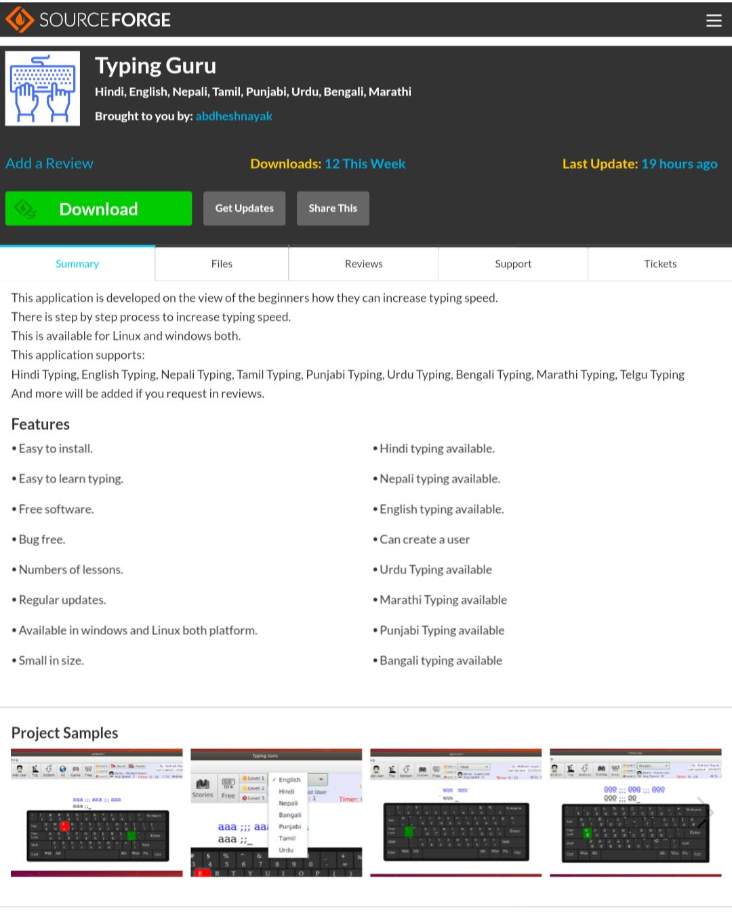

GitHub Link: <https://github.com/abdhesh-nayak/TypingGuru>

Source Forge Link:  <https://sourceforge.net/projects/typingguru/>

**Difficulties in Development**

Problem: After The completion of my project when tried to export it for the users it shows me jdk11 not supports fxdeploy.

Solution: The problem was I used jdk11 which comes without javafx bundle so I learned it from google and changed the jdk11 to jdk1.8 then my problem is solved.

**SOFTWARE AND HARDWARE REQUIREMENT**

**SOFTWARE**

**IntelliJ Idea**

IntelliJ is one of the most powerful and popular Integrated Development Environments (IDE) for Java. It is developed and maintained by **Jet Brains** and available as community and ultimate edition. This feature rich IDE enables rapid development and helps in improving code quality

IDE stands for Integrated Development Environment. It is a combination of multiple tools, which make software development process easier, robust and less error-prone. It has following benefits over plain text editor −

* Integration with useful tools like compiler, debugger, version control system, build tools, various frameworks, application profilers and so on.
* Supports code navigation, code completion, code refactoring and code generation features which boosts development process.
* Supports unit testing, integration testing and code coverage via plug-ins.
* Provides rich set of plug-ins to enhance **IDE** functionality further.

**HARDWARE**

**Laptop**

A laptop computer is a portable personal computer powered by a battery, or an AC cord plugged into an electrical outlet, which is also used to charge the battery. Laptops have an attached keyboard and a touchpad, trackball, or isometric joystick used for navigation. A laptop also has a thin display screen that is attached and can be folded flat for transport.

**Snapshots:**

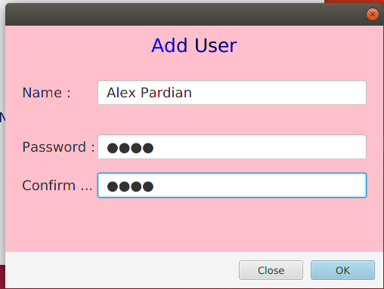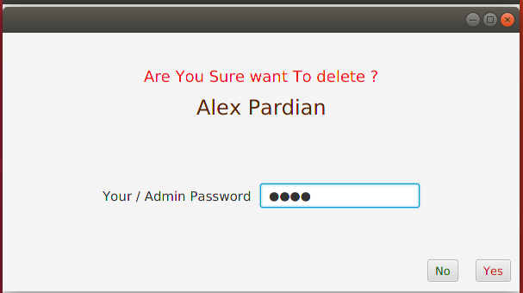

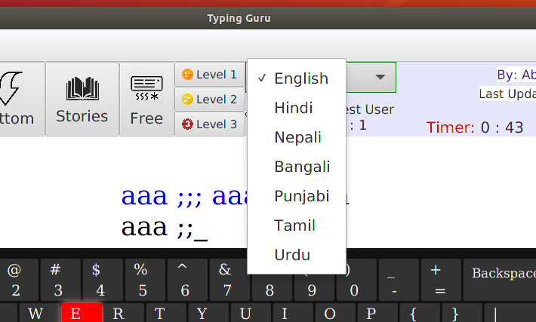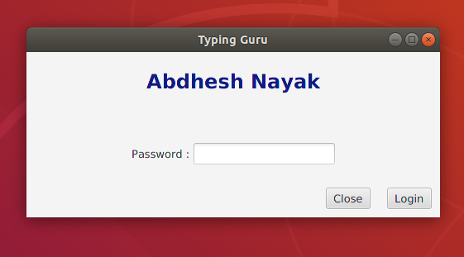 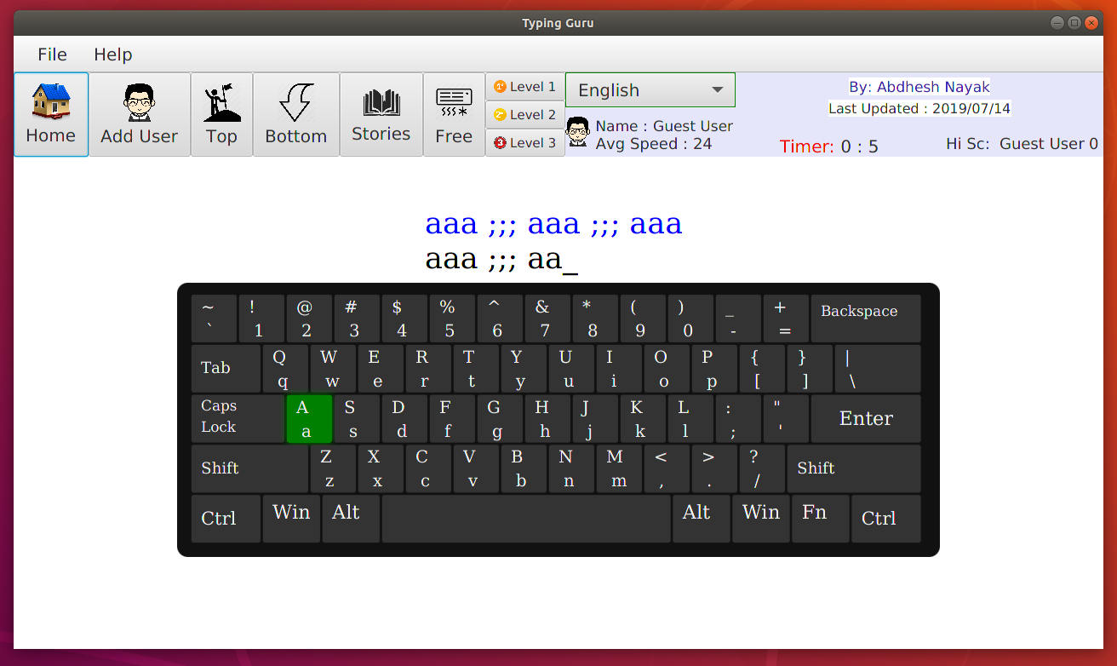 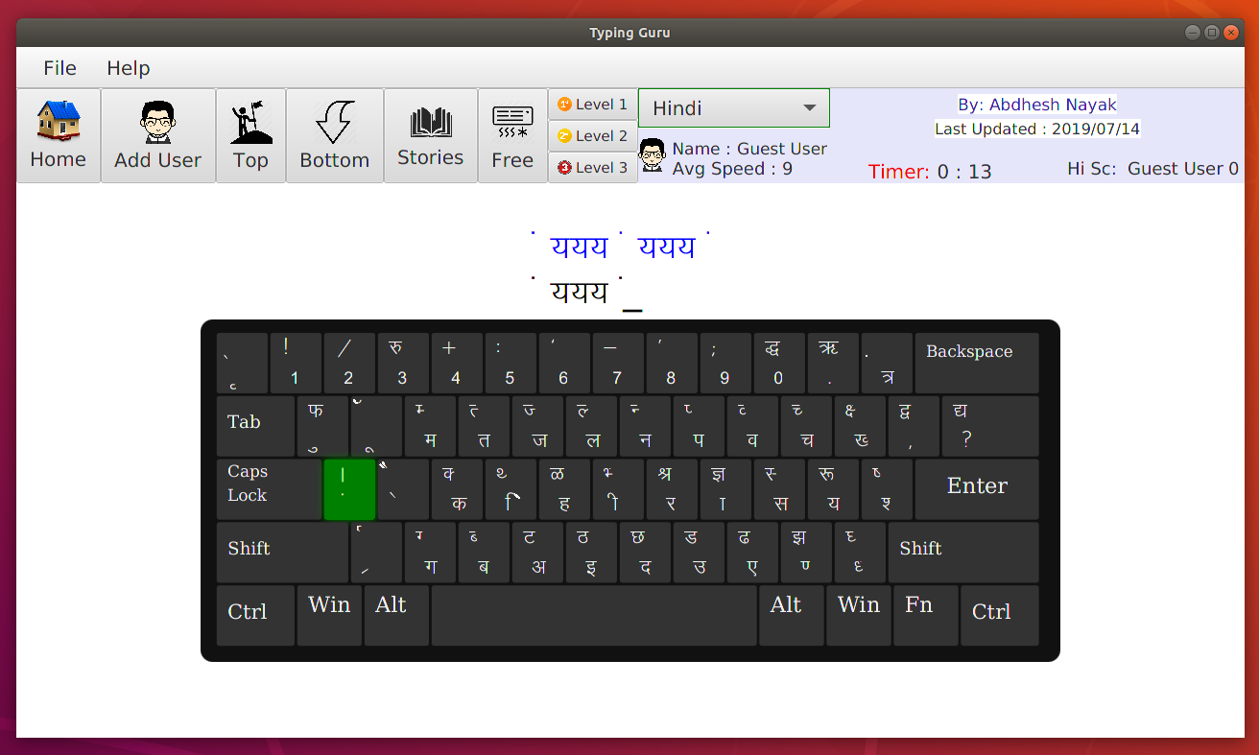 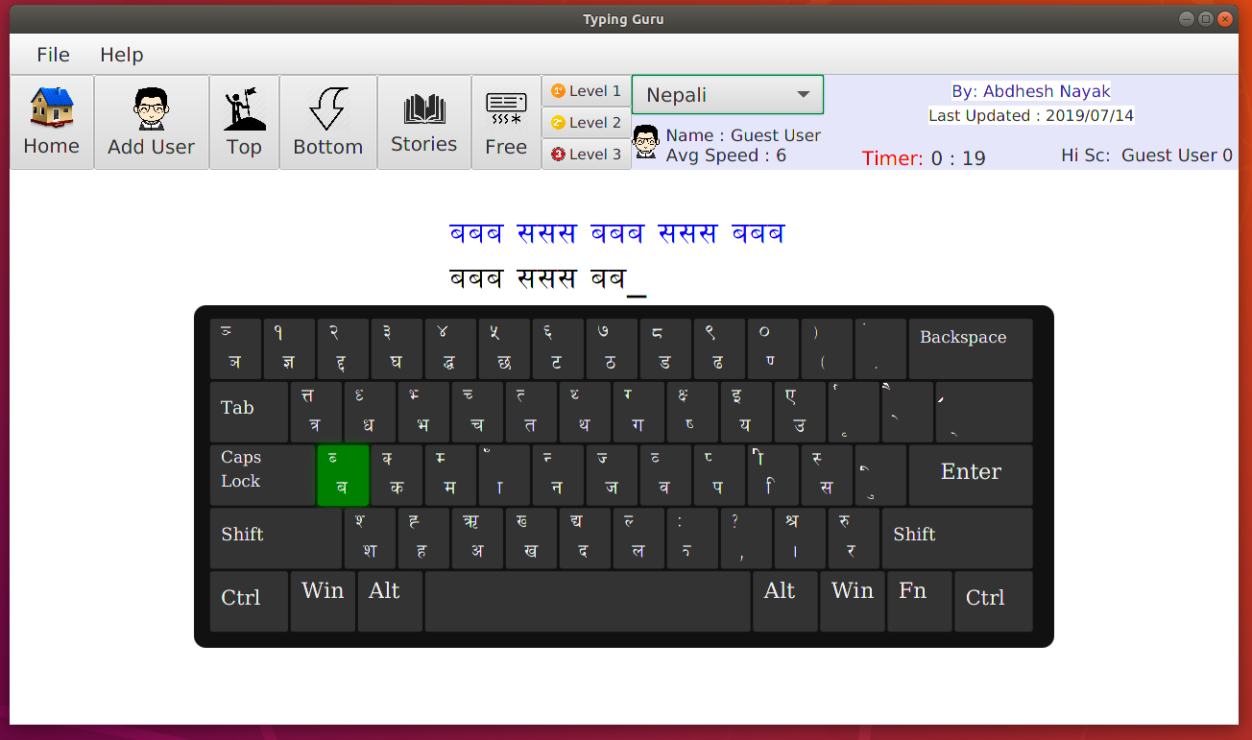 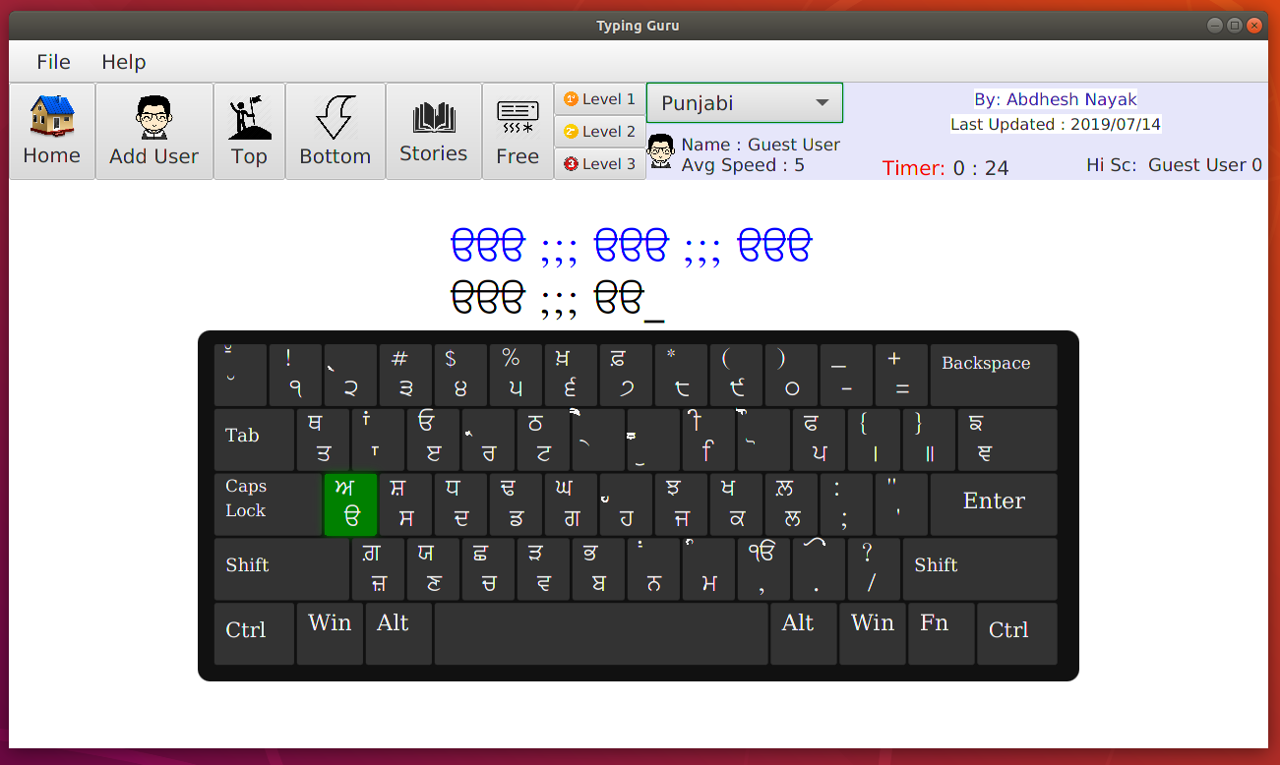 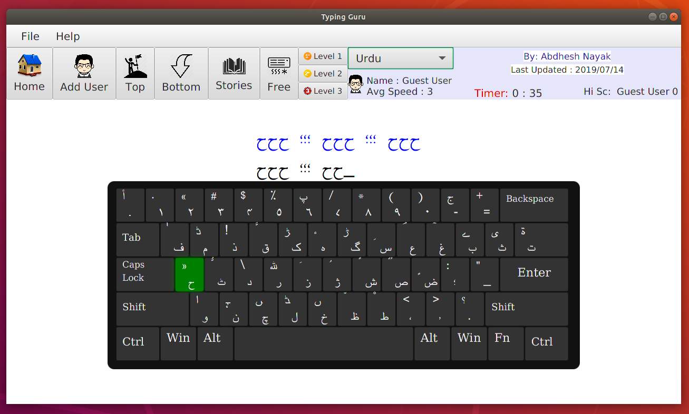 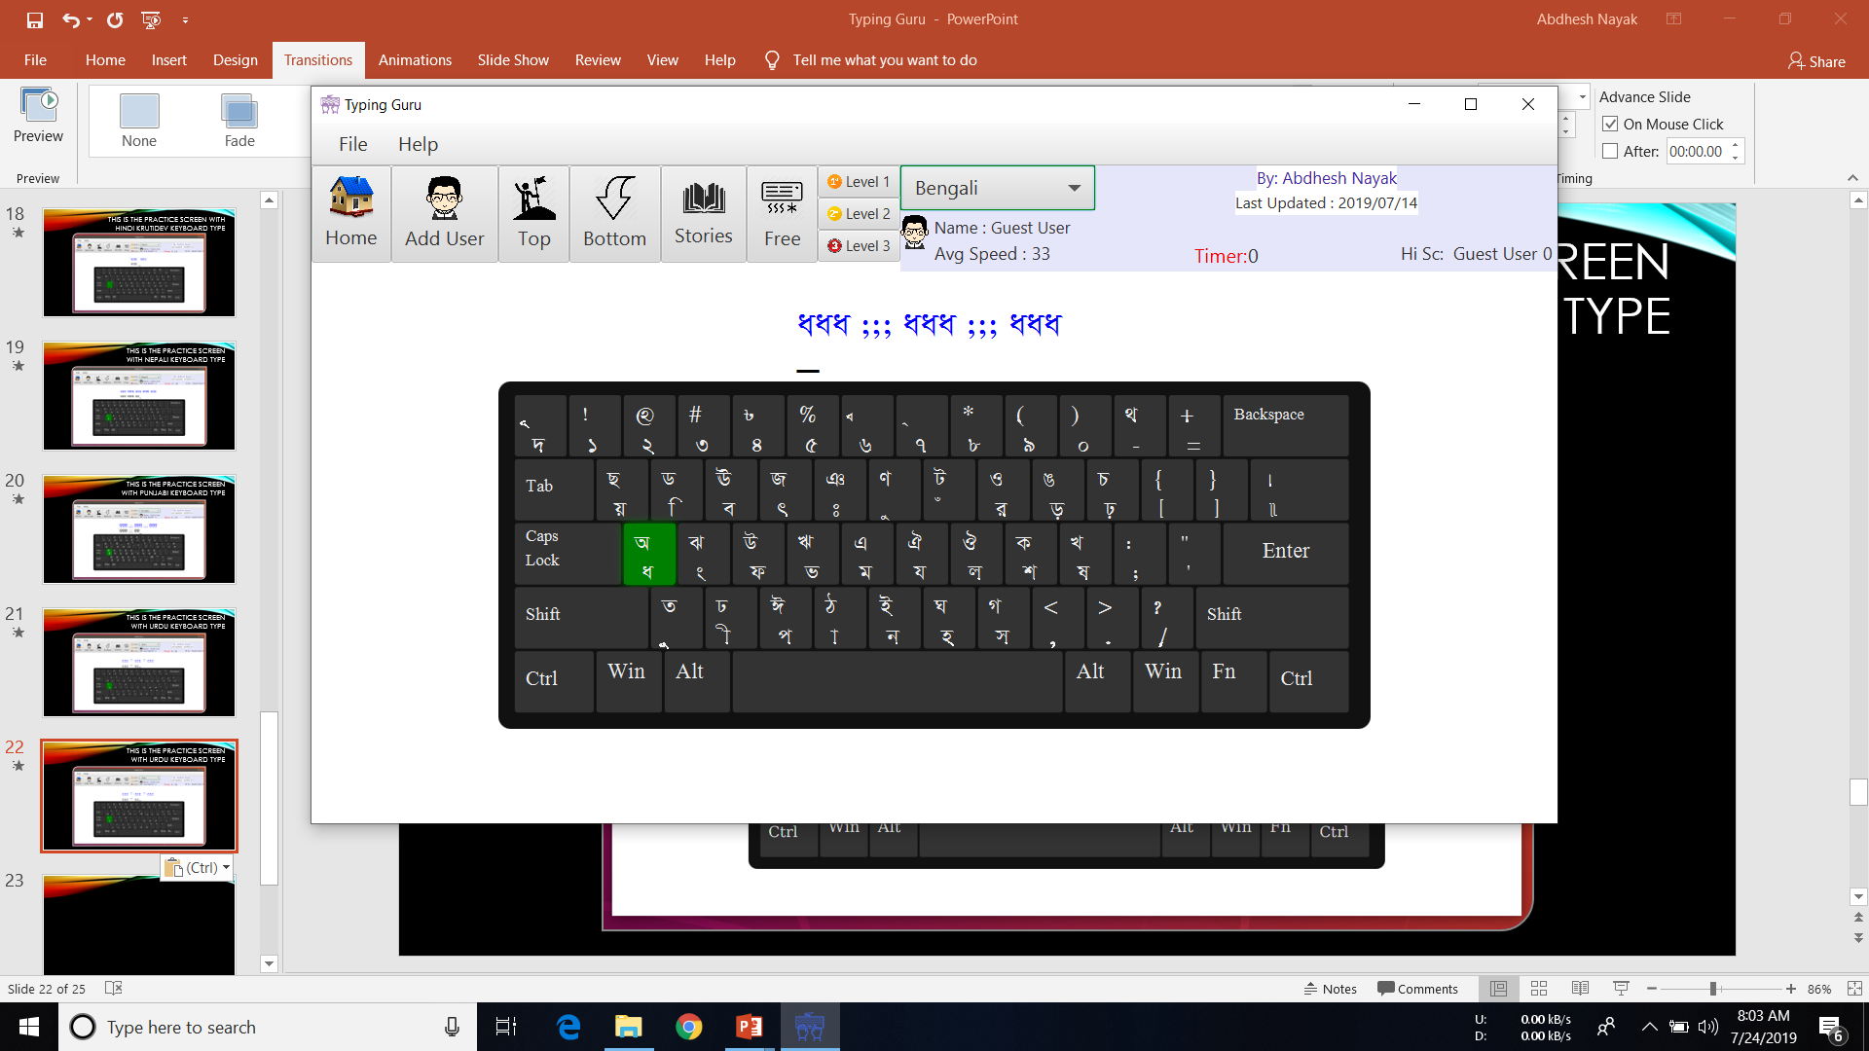 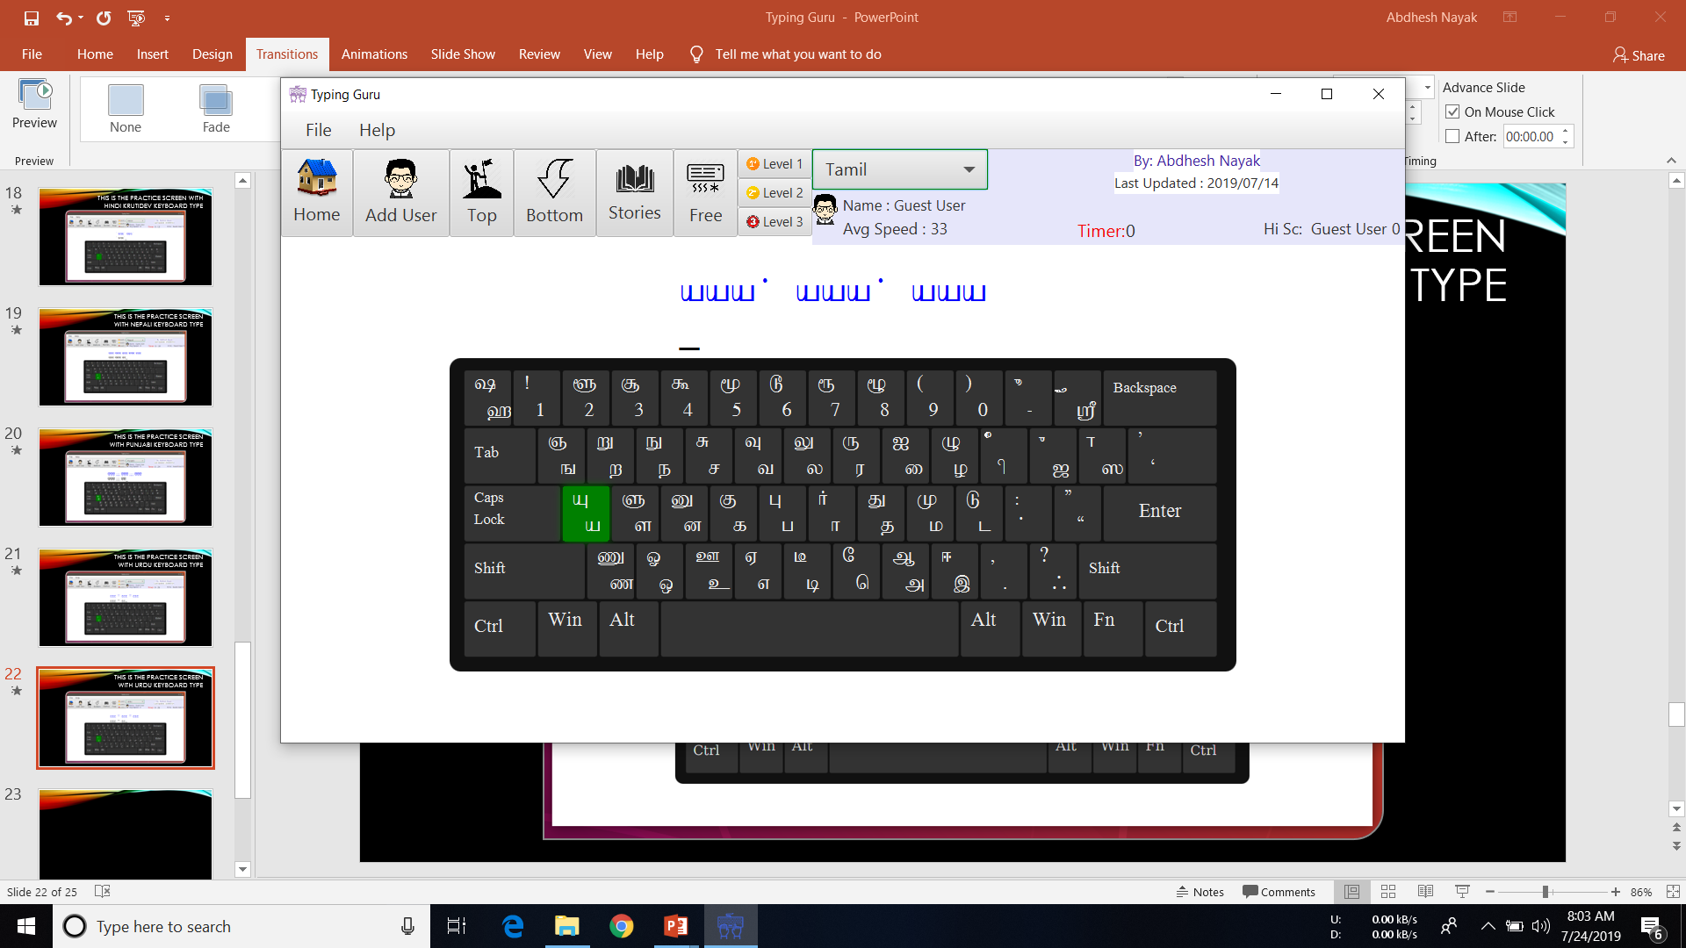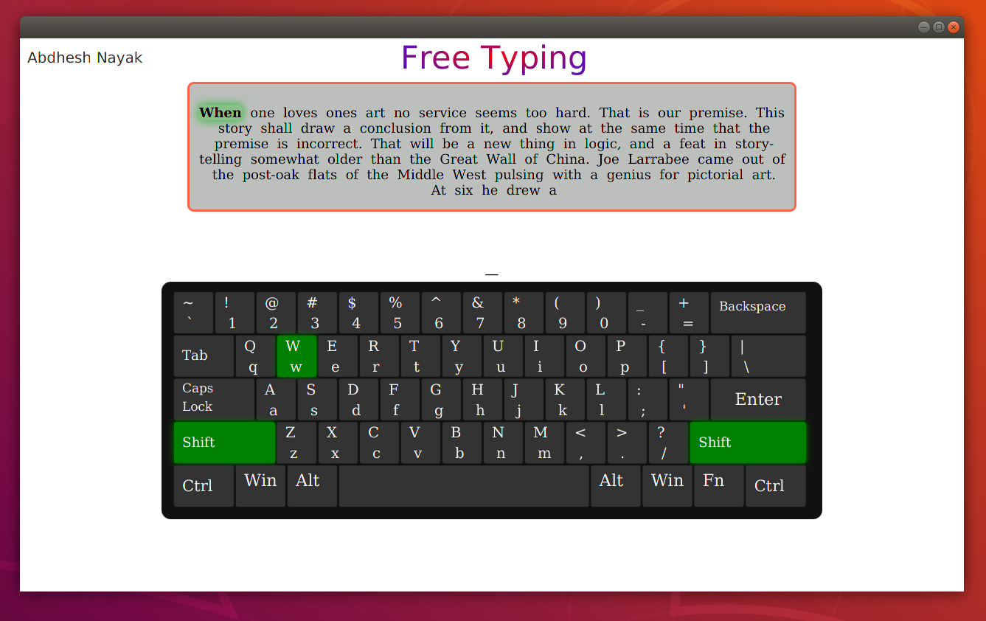

**Source Code:**

|  |
| --- |
| Main.java |

1 package com.abdheshnayak.typingguru;

2

3 import com.abdheshnayak.typingguru.JavaClasses.staticData;

4 import javafx.application.Application;

5 import javafx.fxml.FXMLLoader;

6 import javafx.scene.Parent;

7 import javafx.scene.Scene;

8 import javafx.scene.image.Image;

9 import javafx.stage.Stage;

10

11 import java.io.FileInputStream;

12

13 public class Main extends Application {

14

15 @Override

16 public void start(Stage primaryStage) throws Exception{

17 System.out.println("Program Started Succesfully");

18 // staticData.usrname=a.usrdata.users.get()

19 // Parent root = FXMLLoader.load(getClass().getResource("FreeWriting.fxml"));

20 Parent root = FXMLLoader.load(getClass().getResource("UserSelector.fxml"));

21 // Parent root = FXMLLoader.load(getClass().getResource("ExampleFxml.fxml"));

22 primaryStage.setTitle("Typing Guru");

23

24 FileInputStream input = new FileInputStream(staticData.myDir+"/.src/Images/Icons/DialogIcon.png");

25

26 primaryStage.getIcons().add(new Image(input));

27 // primaryStage.setScene(new Scene(root,1280,740));

28 primaryStage.setScene(new Scene(root, 600, 400));

29 primaryStage.show();

30 }

31

32

33 public static void main(String[] args) {

34 staticData.myDir=System.getProperty("user.dir");

35 // System.out.println(staticData.myDir);

36 launch(args);

37 }

38 }

39

|  |
| --- |
| MainWindowController.java |

1 package com.abdheshnayak.typingguru;

2

3

4 import com.abdheshnayak.typingguru.JavaClasses.fileReaderClass;

5 import com.abdheshnayak.typingguru.JavaClasses.staticData;

6 import com.abdheshnayak.typingguru.JavaClasses.tempDatas;

7 import javafx.animation.Animation;

8 import javafx.animation.KeyFrame;

9 import javafx.animation.Timeline;

10 import javafx.event.ActionEvent;

11 import javafx.event.EventHandler;

12 import javafx.fxml.FXML;

13 import javafx.fxml.FXMLLoader;

14 import javafx.scene.Scene;

15 import javafx.scene.control.*;

16 import javafx.scene.image.Image;

17 import javafx.scene.image.ImageView;

18 import javafx.scene.input.KeyEvent;

19 import javafx.scene.input.MouseEvent;

20 import javafx.scene.layout.BorderPane;

21 import javafx.scene.layout.GridPane;

22 import javafx.scene.web.WebEngine;

23 import javafx.scene.web.WebView;

24 import javafx.stage.Stage;

25 import javafx.stage.WindowEvent;

26 import javafx.util.Duration;

27

28 import java.io.FileInputStream;

29 import java.io.FileNotFoundException;

30 import java.io.IOException;

31 import java.util.HashMap;

32 import java.util.Map;

33 import java.util.Optional;

34

35 import static com.abdheshnayak.typingguru.JavaClasses.SorterClass.ASC;

36 import static com.abdheshnayak.typingguru.JavaClasses.SorterClass.sortByComparator;

37

38 public class MainWindowController {

39

40 public static Stage stage = new Stage();

41 @FXML

42 private MenuItem aboutAppbtn;

43

44 @FXML

45 private ImageView StoriesIcon;

46 @FXML

47 private Button btnStories;

48 @FXML

49 private ChoiceBox LanguageSelector;

50 @FXML

51 private MenuItem quite;

52 @FXML

53 private Label DevLevel;

54 @FXML

55 private Button btnFree;

56 @FXML

57 private Label highScoreLablename;

58 @FXML

59 private Label highScoreLable;

60 @FXML

61 private Label timerLabel;

62 @FXML

63 private Label speedLabel;

64 @FXML

65 private Button btnBottom;

66 @FXML

67 private Button btnTop;

68 @FXML

69 private Label userNameLabel;

70 @FXML

71 private GridPane MainGridPane;

72 @FXML

73 private ImageView adduserIcon;

74 @FXML

75 private Button btnAddUser;

76 @FXML

77 public WebView webopen;

78 @FXML

79 private ImageView userIcon;

80 @FXML

81 private ImageView level1Icon;

82 @FXML

83 private ImageView level2Icon;

84 @FXML

85 private ImageView level3Icon;

86 // @FXML

87 // private ImageView AllIcon;

88 // @FXML

89 // private ImageView GameIcon;

90 @FXML

91 private ImageView FreeIcon;

92 @FXML

93 private ImageView bottomIcon;

94 @FXML

95 private ImageView topicon;

96 @FXML

97 private ImageView HomeIcon;

98 // @FXML

99 // private ImageView npflag;

100 // @FXML

101 // private ImageView Enflag;

102 // @FXML

103 // private Label userinput1;

104 // @FXML

105 // private Label userinput2;

106 // @FXML

107 // private Label userinput3;

108 // @FXML

109 // private Label taskuser;

110 @FXML

111 private Button btnNepali;

112 @FXML

113 private Button btnEnglish;

114 private String task;

115 private String taskC;

116 // @FXML

117 // private Button btnHome;

118 // @FXML

119 // private Button btnAll;

120 // @FXML

121 // private Button btnGame;

122 // @FXML

123 // private Button btnFree;

124 @FXML

125 private Button level1;

126 @FXML

127 private Button level2;

128 @FXML

129 private Map<String, Integer> keys = new HashMap<>();

130 @FXML

131 private Button level3;

132 private String tempKeyboard;

133 private static tempDatas td=new tempDatas();

134

135

136 private void setImageFun() throws IOException {

137

138 FileInputStream input = new FileInputStream(staticData.myDir+"/.src/Images/Icons/usericon.png");

139 Image image = new Image(input);

140 userIcon.setImage(image);

141

142

143 // input = new FileInputStream(staticData.myDir+"/.src/Images/Icons/nepali-flag.png");

144 // image = new Image(input);

145 // npflag.setImage(image);

146

147 input = new FileInputStream(staticData.myDir+"/.src/Images/Icons/usericon.png");

148 image = new Image(input);

149 adduserIcon.setImage(image);

150

151

152 // input = new FileInputStream(staticData.myDir+"/.src/Images/Icons/english-flag.png");

153 // image = new Image(input);

154 // Enflag.setImage(image);

155

156 input = new FileInputStream(staticData.myDir+"/.src/Images/Icons/home.png");

157 image = new Image(input);

158 HomeIcon.setImage(image);

159

160 input = new FileInputStream(staticData.myDir+"/.src/Images/Icons/topIcon.png");

161 image = new Image(input);

162 topicon.setImage(image);

163

164

165 input = new FileInputStream(staticData.myDir+"/.src/Images/Icons/Down.png");

166 image = new Image(input);

167 bottomIcon.setImage(image);

168

169 input = new FileInputStream(staticData.myDir+"/.src/Images/Icons/Stories.png");

170 image = new Image(input);

171 StoriesIcon.setImage(image);

172

173 // input = new FileInputStream(staticData.myDir+"/.src/Images/Icons/game.png");

174 // image = new Image(input);

175 // GameIcon.setImage(image);

176

177 input = new FileInputStream(staticData.myDir+"/.src/Images/Icons/freeWriting.png");

178 image = new Image(input);

179 FreeIcon.setImage(image);

180

181 input = new FileInputStream(staticData.myDir+"/.src/Images/Icons/level1icon.png");

182 image = new Image(input);

183 level1Icon.setImage(image);

184

185

186 input = new FileInputStream(staticData.myDir+"/.src/Images/Icons/level2icon.png");

187 image = new Image(input);

188 level2Icon.setImage(image);

189

190 input = new FileInputStream(staticData.myDir+"/.src/Images/Icons/level3icon.png");

191 image = new Image(input);

192 level3Icon.setImage(image);

193 keyboardLoad();

194 }

195

196 private void keyboardLoad() {

197 WebEngine webEngine= webopen.getEngine();

198 webEngine.load(tempKeyboard);

199 }

200

201 public void QuiteAction(ActionEvent actionEvent) {

202

203 Stage s= (Stage) btnBottom.getScene().getWindow();

204 s.close();

205

206 }

207

208 public void LanguageController(ActionEvent actionEvent) throws IOException, ClassNotFoundException {

209

210 if(actionEvent.getSource().equals(LanguageSelector)) {

211 staticData.unvLanguage=LanguageSelector.getValue().toString();

212 td.hw.ChangeLanguage(LanguageSelector.getValue().toString());

213 td.t.run();

214 keyboardLoad();

215 }

216

217 }

218

219 public void AboutAppFun(ActionEvent actionEvent) throws IOException {

220 if (td.dialogptr) {

221 td.dialogptr = false;

222

223 FileInputStream input = new FileInputStream(staticData.myDir + "/.src/Images/Icons/DialogIcon.png");

224 stage.getIcons().add(new Image(input));

225 // Stage stage = (Stage) btnBottom.getScene().getWindow();

226 GridPane root;

227

228

229 root = (GridPane) FXMLLoader.load(getClass().getResource("aboutApp.fxml"));

230 Scene scene = new Scene(root, 960, 540);

231 stage.setScene(scene);

232

233

234 stage.showAndWait();

235

236

237 td.dialogptr = true;

238

239

240 }

241 }

242

243

244 public class Backgrounds{

245

246 public void go(){

247 final Timeline timeline=new Timeline(

248 new KeyFrame(

249 Duration.seconds(1),

250 event -> {

251 if(staticData.tempSwitch){

252 staticData.timerSeconds++;

253

254

255 // timerLabel.setText(String.valueOf(staticData.timerSeconds));

256 // System.out.println(k);

257

258

259 int pt,second,minute;

260 second=staticData.timerSeconds;

261 pt=second/60;

262 minute=pt;

263 pt=60*pt;

264 second=second-pt;

265

266 timerLabel.setText(" "+minute+" : "+second);

267

268

269 float tend,diff;

270 int fspeed;

271 tend=staticData.timerSeconds;

272 diff=tend/td.spaceCounter;

273 // difrnc=difftime(tend,tstart);

274 // System.out.println("tend: "+tend+" diff :"+diff+" Space Counter :"+td.spaceCounter);

275 fspeed=(int)(60/diff);

276

277 speedLabel.setText(String.valueOf(fspeed));

278 if(staticData.timerSeconds%100==0){

279 if(td.user.usrdata.Score.get(staticData.usrname)<fspeed) {

280 td.user.usrdata.Score.replace(staticData.usrname,fspeed);

281 try {

282 td.user.writeUsers();

283 } catch (IOException e) {

284 e.printStackTrace();

285 }

286 }

287 }

288 }

289 }

290 )

291 );

292 timeline.setCycleCount(Animation.INDEFINITE);

293 timeline.play();

294 }

295

296 }

297

298

299

300 public void initializeHelper() throws IOException, ClassNotFoundException {

301

302 td.user.readUsers();

303 if(!td.user.usrdata.Score.containsKey(staticData.usrname)){

304 td.user.usrdata.Score.put(staticData.usrname,0);

305 }

306

307

308 Map<String, Integer> sortedMapAsc;

309 sortedMapAsc= sortByComparator(td.user.usrdata.Score, ASC);

310 String[] keysName = sortedMapAsc.keySet().toArray(new String[0]);

311

312 highScoreLablename.setText(keysName[0]);

313 highScoreLable.setText(String.valueOf(td.user.usrdata.Score.get(keysName[0])));

314

315 Backgrounds backgrounds=new Backgrounds();

316 backgrounds.go();

317

318 td.t= new Thread(td.hw);

319

320 userNameLabel.setText(staticData.usrname);

321

322 String filename ;

323 filename=staticData.myDir+"/.src/lesson/"+td.lsnlist.get(0);

324 fileReaderClass f = new fileReaderClass(filename);

325 td.lsn= f.run();

326 td.toPrint="";

327 String[] lsnparts= td.lsn.split("");

328 for(int i = 0 ;i<20;i++){

329 td.toPrint=td.toPrint+lsnparts[i];

330 }

331 td.tempString="";

332 for(int i = 1 ;i<20;i++){

333 td.tempString=td.tempString+lsnparts[i];

334 }

335 task=td.toPrint;

336 // taskuser.setText(td.toPrint);

337 // userinput1.setText("_");

338 // userinput2.setText(td.tempString);

339 td.temp1=td.toPrint.split("");

340 taskC="_";

341 // System.out.println(taskC);

342 keys.clear();

343 keys.put(td.temp1[td.cursorPointer],1);

344 td.hw.write(keys,task,taskC);

345 td.t.run();

346

347

348 }

349

350

351 public void initialize() throws IOException, ClassNotFoundException {

352

353 td.addLessons();

354

355

356

357

358 DevLevel.setText("By: Abdhesh Nayak");

359 tempKeyboard="file://"+staticData.myDir+"/.src/Images/keyboard/tempKeyboard.html";

360

361 td.user.readUsers();

362 if(!td.user.usrdata.Score.containsKey(staticData.usrname)){

363 td.user.usrdata.Score.put(staticData.usrname,0);

364 }

365

366

367 Map<String, Integer> sortedMapAsc;

368 sortedMapAsc= sortByComparator(td.user.usrdata.Score, ASC);

369 String[] keysName = sortedMapAsc.keySet().toArray(new String[0]);

370

371 highScoreLablename.setText(keysName[0]);

372 highScoreLable.setText(String.valueOf(td.user.usrdata.Score.get(keysName[0])));

373

374 Backgrounds backgrounds=new Backgrounds();

375 backgrounds.go();

376

377 td.t= new Thread(td.hw);

378

379 userNameLabel.setText(staticData.usrname);

380

381 String filename ;

382 filename=staticData.myDir+"/.src/lesson/"+td.lsnlist.get(0);

383 fileReaderClass f = new fileReaderClass(filename);

384 td.lsn= f.run();

385 td.toPrint="";

386 String[] lsnparts= td.lsn.split("");

387 for(int i = 0 ;i<20;i++){

388 td.toPrint=td.toPrint+lsnparts[i];

389 }

390 td.tempString="";

391 for(int i = 1 ;i<20;i++){

392 td.tempString=td.tempString+lsnparts[i];

393 }

394 task=td.toPrint;

395 // taskuser.setText(td.toPrint);

396 // userinput1.setText("_");

397 // userinput2.setText(td.tempString);

398 td.temp1=td.toPrint.split("");

399 taskC="_";

400 // System.out.println(taskC);

401 keys.clear();

402 keys.put(td.temp1[td.cursorPointer],1);

403 td.hw.write(keys,task,taskC);

404 td.t.run();

405 setImageFun();

406

407 LanguageSelector.getItems().clear();

408 String[] lg = td.languages.values().toArray(new String[0]);

409 LanguageSelector.getItems().addAll(lg);

410

411 LanguageSelector.setValue("English");

412

413

414 }

415

416

417

418 public void onHandleKeyPressed(KeyEvent keyEvent) throws IOException{

419 int x;

420 try {

421 x= (int) keyEvent.getText().charAt(0);

422 }catch (Exception e){

423 keys.clear();

424 keys.put(keyEvent.getCode().toString(),2);

425 keys.put(td.temp1[0],1);

426 td.hw.write(keys,task,taskC);

427 td.t.run();

428 keyboardLoad();

429 return;

430 }

431

432 if(x==8 ||x==127||x==16||(keyEvent.getText().equals("CAPS"))||(keyEvent.getText().equals("ESCAPE")))

433 {

434 keys.clear();

435 keys.put(keyEvent.getCode().toString(),2);

436 keys.put(td.temp1[td.cursorPointer],1);

437 td.hw.write(keys,task,taskC);

438 td.t.run();

439 keyboardLoad();

440 return;

441 }

442 String[] lsnparts= td.lsn.split("");

443 String tempStr;

444 tempStr=keyEvent.getText();

445

446 if(keyEvent.isShiftDown()){

447 tempStr=td.is.convert(tempStr);

448 }

449 if(tempStr.equals(lsnparts[td.cursorPointer])){

450 if(!staticData.tempSwitch){

451 staticData.tempSwitch=true;

452 }

453 if(lsnparts[td.cursorPointer].equals(" ")){

454 td.spaceCounter++;

455 }

456 //td.spaceCounter++;

457 td.toPrint="";

458 if(td.cursorPointer==td.lsn.length()){

459 td.lsnNext();

460 }

461 td.cursorPointer++;

462 if(td.cursorPointer%20==0) {

463 td.lstcursorPointer=td.cursorPointer;

464 for (int i = td.cursorPointer; i < td.cursorPointer + 20; i++) {

465 td.toPrint = td.toPrint + lsnparts[i];

466 }

467 task=td.toPrint;

468 // taskuser.setText(td.toPrint);

469 }

470

471 td.toPrint= "";

472 for (int i = td.lstcursorPointer; i < td.cursorPointer; i++) {

473 td.toPrint = td.toPrint + lsnparts[i];

474 }

475 td.toPrint=td.toPrint+"_";

476 taskC=td.toPrint;

477 // userinput1.setText(td.toPrint);

478

479 td.toPrint= "";

480 for (int i = td.cursorPointer; i < td.lstcursorPointer+20; i++) {

481 td.toPrint = td.toPrint + lsnparts[i];

482 }

483 td.tempString="";

484 for (int i = td.cursorPointer+1; i < td.lstcursorPointer+20; i++) {

485 td.tempString=td.tempString + lsnparts[i];

486 }

487 // userinput2.setText(td.tempString);

488 td.temp1=td.toPrint.split("");

489

490 if(td.temp1[0].equals(" ")){

491 td.temp1[0]="SPACE";

492 }

493

494 keys.clear();

495 keys.put(tempStr,0);

496 keys.put(td.temp1[0],1);

497

498 td.hw.write(keys,task,taskC);

499 td.t.run();

500

501 keyboardLoad();

502

503 }

504 else {

505 td.toPrint= "";

506 for (int i = td.lstcursorPointer; i < td.cursorPointer; i++) {

507 td.toPrint = td.toPrint + lsnparts[i];

508 }

509 td.toPrint=td.toPrint+"_";

510 // userinput1.setText(td.toPrint);

511

512 taskC=td.toPrint;

513 String temp;

514 temp= tempStr;

515

516 switch (keyEvent.getCode().toString()){

517 case "ESCAPE":

518 temp="ESCAPE";

519 break;

520 case "SPACE":

521 temp="SPACE";

522 break;

523 case "ENTER":

524 temp="ENTER";

525 break;

526 case "BACK_SPACE":

527 temp="BACK_SPACE";

528 break;

529 case "TAB":

530 temp="TAB";

531

532 }

533

534 keys.clear();

535 keys.put(temp,2);

536 keys.put(td.temp1[0],1);

537 td.hw.write(keys,task,taskC);

538 td.t.run();

539 keyboardLoad();

540

541 td.toPrint= "";

542 for (int i = td.cursorPointer+1; i < td.lstcursorPointer+20; i++) {

543 td.toPrint = td.toPrint + lsnparts[i];

544 }

545 // userinput2.setText(td.toPrint);

546 }

547 }

548

549

550 public void mouceClickedAction(MouseEvent mouseEvent) throws IOException, ClassNotFoundException {

551 staticData.tempSwitch=false;

552 staticData.timerSeconds=0;

553 td.spaceCounter=0;

554

555 String filename ;

556 filename = staticData.myDir+"/.src/lesson/"+td.lsnlist.get(0);

557 if(mouseEvent.getSource().equals(level1)) {

558 filename = staticData.myDir+"/.src/lesson/"+td.lsnlist.get(0);

559 }else if (mouseEvent.getSource().equals(level2)) {

560 filename = staticData.myDir+"/.src/lesson/"+td.lsnlist.get(20);

561 }else if (mouseEvent.getSource().equals(level3)) {

562 filename = staticData.myDir+"/.src/lesson/"+td.lsnlist.get(30);

563

564 }else if(mouseEvent.getSource().equals(btnNepali)){

565 // td.cursorPointer=0;

566 WebEngine webEngine= webopen.getEngine();

567 staticData.keyBoardType=false;

568

569 staticData.unvLanguage=LanguageSelector.getValue().toString();

570 td.hw.ChangeLanguage(LanguageSelector.getValue().toString());

571 // td.hw.run();

572 // webEngine.load("file://"+staticData.myDir+"/.src/Images/keyboard/tempKeyboard.html");

573 //

574 // return;

575 }else if(mouseEvent.getSource().equals(btnEnglish)) {

576 // td.cursorPointer=0;

577 WebEngine webEngine = webopen.getEngine();

578 staticData.keyBoardType=true;

579 // taskC="";

580 // td.hw.write(keys,task,taskC);

581

582 staticData.unvLanguage=LanguageSelector.getValue().toString();

583 td.hw.ChangeLanguage(LanguageSelector.getValue().toString());

584 // td.hw.run();

585 // webEngine.load("file://"+staticData.myDir+"/.src/Images/keyboard/tempKeyboard.html");

586 // return;

587

588 }else if(mouseEvent.getSource().equals(btnTop)||mouseEvent.getSource().equals(btnBottom)){

589 if(mouseEvent.getSource().equals(btnTop)){

590 staticData.order=1;

591 }else{

592 staticData.order=2;

593 }

594 // System.out.println("btnTop Clicked");

595 if(td.dialogptr) {

596 td.dialogptr = false;

597

598 Stage stage = new Stage();

599

600 FileInputStream input = new FileInputStream(staticData.myDir+"/.src/Images/Icons/DialogIcon.png");

601 stage.getIcons().add(new Image(input));

602

603 BorderPane root;

604

605 root = (BorderPane) FXMLLoader.load(getClass().getResource("topUsersView.fxml"));

606 Scene scene = new Scene(root, 800, 600);

607 stage.setScene(scene);

608 stage.showAndWait();

609 td.dialogptr=true;

610 }

611

612 }else if (mouseEvent.getSource().equals(btnAddUser)){

613 userDialog("addUserWindow.fxml");

614 return;

615 }else if(mouseEvent.getSource().equals(btnStories)){

616 if(td.dialogptr) {

617 staticData.keyBoardType=true;

618 td.dialogptr = false;

619 System.out.println("Free Button");

620

621 FileInputStream input = new FileInputStream(staticData.myDir+"/.src/Images/Icons/DialogIcon.png");

622 stage.getIcons().add(new Image(input));

623 // Stage stage = (Stage) btnBottom.getScene().getWindow();

624 GridPane root;

625

626

627 root = (GridPane) FXMLLoader.load(getClass().getResource("StoriesTyping.fxml"));

628 Scene scene = new Scene(root, 1280, 770);

629 stage.setScene(scene);

630

631

632

633 stage.showAndWait();

634

635

636

637 td.dialogptr=true;

638 staticData.timerSeconds=0;

639 // StoriesTyping.backgrounds.timeline.stop();

640

641

642 }

643 }else if(mouseEvent.getSource().equals(btnFree)){

644 if(td.dialogptr) {

645 td.dialogptr = false;

646 // System.out.println("Free Button");

647 Stage stage = new Stage();

648

649 FileInputStream input = new FileInputStream(staticData.myDir+"/.src/Images/Icons/DialogIcon.png");

650 stage.getIcons().add(new Image(input));

651

652 // Stage stage = (Stage) btnBottom.getScene().getWindow();

653 GridPane root;

654

655

656 root = (GridPane) FXMLLoader.load(getClass().getResource("FreeWriting.fxml"));

657 Scene scene = new Scene(root, 1280, 750);

658 stage.setScene(scene);

659

660

661 stage.showAndWait();

662

663 td.dialogptr=true;

664 staticData.timerSeconds=0;

665 // StoriesTyping.backgrounds.timeline.stop();;

666

667 }

668 }else {

669 filename = staticData.myDir+"/.src/lesson/"+td.lsnlist.get(0);

670 }

671 fileReaderClass f = new fileReaderClass(filename);

672 td.lsn= f.run();

673

674 td.toPrint="";

675 String[] lsnparts= td.lsn.split("");

676 for(int i = 0 ;i<20;i++){

677 td.toPrint=td.toPrint+lsnparts[i];

678 }

679 td.tempString="";

680 for(int i = 1 ;i<20;i++){

681 td.tempString=td.tempString+lsnparts[i];

682 }

683 task=td.toPrint;

684 // taskuser.setText(td.toPrint);

685 taskC="_";

686 // userinput2.setText(td.tempString);

687 // userinput1.setText("_");

688 // userinput3.setText("");

689 td.cursorPointer=0;

690 td.lstcursorPointer=0;

691 td.temp1=td.toPrint.split("");

692 keys.clear();

693 keys.put(td.temp1[td.cursorPointer],1);

694 td.hw.write(keys,task,taskC);

695 td.t.run();

696 keyboardLoad();

697 }

698

699

700 public void userDialog(String fxmlName) throws IOException, ClassNotFoundException {

701 Dialog<ButtonType> dialog = new Dialog<>();

702 dialog.initOwner(MainGridPane.getScene().getWindow());

703 FXMLLoader fxmlLoader= new FXMLLoader();

704 fxmlLoader.setLocation(getClass().getResource(fxmlName));

705 try {

706 dialog.getDialogPane().setContent(fxmlLoader.load());

707 }catch (IOException e){

708 // System.out.println("Exception:");

709 e.printStackTrace();

710 return;

711 }

712

713 // Parent root = FXMLLoader.load(getClass().getResource("addUserWindow.fxml"));

714 // dialog.getDialogPane().setContent(root);

715 // dialog.setTitle("Add New User");

716 dialog.getDialogPane().getButtonTypes().add(ButtonType.OK);

717 dialog.getDialogPane().getButtonTypes().add(ButtonType.CLOSE);

718 // System.out.println("Ok");

719 Optional<ButtonType> result = dialog.showAndWait();

720 if(result.isPresent()&&result.get()==ButtonType.OK){

721 addUserClass newUser = fxmlLoader.getController();

722 if(newUser.save()==1){

723 result=dialog.showAndWait();

724 }

725

726 // System.out.println("OK Pressed");

727

728 }else {

729 // System.out.println("Cancel Pressed");

730 }

731

732

733 }

734

735 }

736

737

738

|  |
| --- |
| Mainwindow.fxml |

1 <?xml version="1.0" encoding="UTF-8"?>

2

3 <?import javafx.geometry.Insets?>

4 <?import javafx.scene.control.Button?>

5 <?import javafx.scene.control.ChoiceBox?>

6 <?import javafx.scene.control.Label?>

7 <?import javafx.scene.control.Menu?>

8 <?import javafx.scene.control.MenuBar?>

9 <?import javafx.scene.control.MenuItem?>

10 <?import javafx.scene.image.ImageView?>

11 <?import javafx.scene.layout.BorderPane?>

12 <?import javafx.scene.layout.ColumnConstraints?>

13 <?import javafx.scene.layout.GridPane?>

14 <?import javafx.scene.layout.HBox?>

15 <?import javafx.scene.layout.RowConstraints?>

16 <?import javafx.scene.layout.VBox?>

17 <?import javafx.scene.web.WebView?>

18

19 <GridPane fx:id="MainGridPane" alignment="center" hgap="10" style="-fx-background-color:white;" vgap="10" xmlns="http://javafx.com/javafx/8.0.211" xmlns:fx="http://javafx.com/fxml/1" fx:controller="com.abdheshnayak.typingguru.MainWindowController">

20 <VBox prefHeight="776.0" prefWidth="1410.0" style="-fx-font-size: 20;-fx-background-color: white;" GridPane.hgrow="ALWAYS" GridPane.vgrow="ALWAYS">

21 <children>

22 <MenuBar VBox.vgrow="NEVER">

23 <menus>

24 <Menu mnemonicParsing="false" text="File">

25 <items>

26 <MenuItem fx:id="quite" mnemonicParsing="false" onAction="#QuiteAction" text="Quit" />

27 </items>

28 </Menu>

29 <Menu mnemonicParsing="false" text="About">

30 <items>

31 <MenuItem mnemonicParsing="false" fx:id="aboutAppbtn" onAction="#AboutAppFun" text="About TypingGuru" />

32 </items>

33 </Menu>

34 </menus>

35 </MenuBar>

36 <BorderPane prefHeight="499.0" prefWidth="902.0" VBox.vgrow="ALWAYS">

37 <top>

38 <HBox prefHeight="78.0" BorderPane.alignment="CENTER">

39 <children>

40 <Button fx:id="btnHome" contentDisplay="TOP" mnemonicParsing="false" onKeyPressed="#onHandleKeyPressed" onMouseClicked="#mouceClickedAction" prefHeight="100.0" text="Home" HBox.hgrow="ALWAYS">

41 <graphic>

42 <ImageView fx:id="HomeIcon" fitHeight="45.0" fitWidth="45.0" pickOnBounds="true" preserveRatio="true">

43 </ImageView>

44 </graphic>

45 </Button>

46 <Button fx:id="btnAddUser" contentDisplay="TOP" mnemonicParsing="false" onKeyPressed="#onHandleKeyPressed" onMouseClicked="#mouceClickedAction" prefHeight="100.0" text="Add User" HBox.hgrow="ALWAYS">

47 <graphic>

48 <ImageView fx:id="adduserIcon" fitHeight="45.0" fitWidth="45.0" pickOnBounds="true" preserveRatio="true" />

49 </graphic>

50 </Button>

51 <Button fx:id="btnTop" contentDisplay="TOP" mnemonicParsing="false" onKeyPressed="#onHandleKeyPressed" onMouseClicked="#mouceClickedAction" prefHeight="100.0" text="Top" HBox.hgrow="ALWAYS">

52 <graphic>

53 <ImageView fx:id="topicon" fitHeight="45.0" fitWidth="45.0" pickOnBounds="true" preserveRatio="true">

54 </ImageView>

55 </graphic>

56 </Button>

57 <Button fx:id="btnBottom" contentDisplay="TOP" mnemonicParsing="false" onKeyPressed="#onHandleKeyPressed" onMouseClicked="#mouceClickedAction" prefHeight="100.0" text="Bottom" HBox.hgrow="ALWAYS">

58 <graphic>

59 <ImageView fx:id="bottomIcon" fitHeight="45.0" fitWidth="45.0" pickOnBounds="true" preserveRatio="true">

60 </ImageView>

61 </graphic>

62 </Button>

63 <Button fx:id="btnStories" contentDisplay="TOP" mnemonicParsing="false" onKeyPressed="#onHandleKeyPressed" onMouseClicked="#mouceClickedAction" prefHeight="100.0" text="Stories" HBox.hgrow="ALWAYS">

64 <graphic>

65 <ImageView fx:id="StoriesIcon" fitHeight="45.0" fitWidth="45.0" pickOnBounds="true" preserveRatio="true">

66 </ImageView>

67 </graphic>

68 </Button>

69 <Button fx:id="btnFree" contentDisplay="TOP" mnemonicParsing="false" onKeyPressed="#onHandleKeyPressed" onMouseClicked="#mouceClickedAction" prefHeight="100.0" text="Free" HBox.hgrow="ALWAYS">

70 <graphic>

71 <ImageView fx:id="FreeIcon" fitHeight="45.0" fitWidth="45.0" pickOnBounds="true" preserveRatio="true">

72 </ImageView>

73 </graphic>

74 </Button>

75 <VBox prefHeight="79.0">

76 <children>

77 <Button fx:id="level1" minHeight="33.0" mnemonicParsing="false" onKeyPressed="#onHandleKeyPressed" onMouseClicked="#mouceClickedAction" prefHeight="30.0" style="-fx-font-size: 15;" text="Level 1">

78 <graphic>

79 <ImageView fx:id="level1Icon" fitHeight="15.0" fitWidth="15.0" pickOnBounds="true" preserveRatio="true">

80 </ImageView>

81 </graphic>

82 </Button>

83 <Button fx:id="level2" minHeight="33.0" mnemonicParsing="false" onKeyPressed="#onHandleKeyPressed" onMouseClicked="#mouceClickedAction" prefHeight="30.0" style="-fx-font-size: 15;" text="Level 2">

84 <graphic>

85 <ImageView fx:id="level2Icon" fitHeight="15.0" fitWidth="15.0" pickOnBounds="true" preserveRatio="true">

86 </ImageView>

87 </graphic>

88 </Button>

89 <Button fx:id="level3" minHeight="33.0" mnemonicParsing="false" onKeyPressed="#onHandleKeyPressed" onMouseClicked="#mouceClickedAction" style="-fx-font-size: 15;" text="Level 3">

90 <graphic>

91 <ImageView fx:id="level3Icon" fitHeight="15.0" fitWidth="15.0" pickOnBounds="true" preserveRatio="true">

92 </ImageView>

93 </graphic>

94 </Button>

95 </children>

96 </VBox>

97 <VBox minWidth="-Infinity" prefHeight="99.0" prefWidth="560.0" style="-fx-background-color: lavender;" HBox.hgrow="ALWAYS">

98 <children>

99 <HBox prefHeight="100.0" prefWidth="200.0" VBox.vgrow="ALWAYS">

100 <children>

101 <ChoiceBox fx:id="LanguageSelector" onAction="#LanguageController" prefWidth="200.0" style="-fx-border-color: green;" />

102 <BorderPane HBox.hgrow="ALWAYS">

103 <center>

104 <Label fx:id="DevLevel" style="-fx-font-size: 17; -fx-background-color: white;" text="By: Abdhesh Nayak" textFill="#42269e" BorderPane.alignment="CENTER" />

105 </center>

106 <bottom>

107 <Label style="-fx-background-color: white;-fx-font-size: 16;" text="Last Updated : 2019/08/10" BorderPane.alignment="CENTER" />

108 </bottom>

109 </BorderPane>

110 </children>

111 </HBox>

112 <VBox>

113 <children>

114 <HBox prefHeight="34.0" prefWidth="699.0" VBox.vgrow="ALWAYS">

115 <children>

116 <ImageView fx:id="userIcon" fitHeight="35.0" fitWidth="40.0" pickOnBounds="true" preserveRatio="true" />

117 <VBox HBox.hgrow="ALWAYS">

118 <children>

119 <HBox>

120 <children>

121 <Label style="-fx-font-size: 17;" text=" Name : " />

122 <Label fx:id="userNameLabel" style="-fx-font-size: 17;" text="Alex Pardian" />

123 </children>

124 </HBox>

125 <HBox>

126 <children>

127 <BorderPane HBox.hgrow="ALWAYS">

128 <left>

129 <HBox BorderPane.alignment="CENTER">

130 <children>

131 <Label style="-fx-font-size: 18;" text=" Avg Speed : " />

132 <Label fx:id="speedLabel" style="-fx-font-size: 18;" text="33" />

133 </children>

134 </HBox>

135 </left>

136 <right>

137 <HBox nodeOrientation="LEFT_TO_RIGHT" BorderPane.alignment="TOP_LEFT">

138 <children>

139 <Label style="-fx-font-size: 18;" text="Hi Sc: " />

140 <Label fx:id="highScoreLablename" style="-fx-font-size: 18;" text="Abdhesh">

141 <HBox.margin>

142 <Insets left="5.0" right="5.0" />

143 </HBox.margin>

144 </Label>

145 <Label fx:id="highScoreLable" style="-fx-font-size: 18;" text="33">

146 <HBox.margin>

147 <Insets bottom="5.0" right="5.0" />

148 </HBox.margin>

149 </Label>

150 </children>

151 </HBox>

152 </right>

153 <center>

154 <HBox alignment="CENTER" BorderPane.alignment="CENTER">

155 <children>

156 <Label text="Timer:" textFill="#f50000" />

157 <Label fx:id="timerLabel" text="0" />

158 </children>

159 </HBox>

160 </center>

161 </BorderPane>

162 </children>

163 </HBox>

164 </children>

165 </VBox>

166 </children>

167 </HBox>

168 </children>

169 </VBox>

170 </children>

171 </VBox>

172 </children>

173 </HBox>

174 </top>

175 <bottom>

176 <WebView fx:id="webopen" maxWidth="960.0" minHeight="550.0" prefHeight="399.0" prefWidth="600.0" BorderPane.alignment="BOTTOM_CENTER" />

177 </bottom>

178 </BorderPane>

179 </children>

180 </VBox>

181 <columnConstraints>

182 <ColumnConstraints />

183 </columnConstraints>

184 <rowConstraints>

185 <RowConstraints />

186 </rowConstraints>

187 </GridPane>

188

|  |
| --- |
| passwordChecker.java |

1 package com.abdheshnayak.typingguru;

2

3 import com.abdheshnayak.typingguru.JavaClasses.staticData;

4 import javafx.event.ActionEvent;

5 import javafx.fxml.FXML;

6 import javafx.fxml.FXMLLoader;

7 import javafx.scene.Scene;

8 import javafx.scene.control.Button;

9 import javafx.scene.control.Label;

10 import javafx.scene.control.PasswordField;

11 import javafx.scene.input.MouseEvent;

12 import javafx.scene.layout.GridPane;

13 import javafx.stage.Stage;

14

15 import java.io.IOException;

16

17 public class passwordChecker {

18 @FXML

19 private Label wrongLabel;

20 @FXML

21 private PasswordField passwordField;

22 @FXML

23 private Button closebtn;

24 @FXML

25 private Button loginbtn;

26 @FXML

27 private Label UserName;

28

29 public void initialize() {

30 UserName.setText(staticData.usrname);

31 }

32

33 public void onMouceclickHandle(MouseEvent mouseEvent) throws IOException, ClassNotFoundException {

34 if (mouseEvent.getSource().equals(closebtn)) {

35 Stage stage = (Stage) closebtn.getScene().getWindow();

36 stage.close();

37

38 // Stage stage = new Stage();

39 GridPane root;

40 root = (GridPane) FXMLLoader.load(getClass().getResource("UserSelector.fxml"));

41 // PasswordChecker ps = new PasswordChecker();

42 // ps.usr= choicebox.getValue().toString();

43 Scene scene = new Scene(root, 600, 400);

44 stage.setScene(scene);

45 stage.show();

46 } else if (mouseEvent.getSource().equals(loginbtn)) {

47

48 addUserClass usr = new addUserClass();

49 usr.readUsers();

50 if (usr.usrdata.users.containsKey(staticData.usrname)) {

51 if (passwordField.getText().trim().equals(usr.usrdata.users.get(staticData.usrname))) {

52 Stage stage = (Stage) loginbtn.getScene().getWindow();

53 stage.close();

54 // Stage stage = new Stage();

55 GridPane root;

56 root = (GridPane) FXMLLoader.load(getClass().getResource("Mainwindow.fxml"));

57 // PasswordChecker ps = new PasswordChecker();

58 // ps.usr= choicebox.getValue().toString();

59 Scene scene = new Scene(root, 1280, 720);

60 stage.setScene(scene);

61 stage.show();

62 }else {

63

64 wrongLabel.setText("Wrong Password Try Again !!");

65 passwordField.clear();

66 }

67 }

68 }

69 }

70

71 public void onEnterClicked(ActionEvent event) throws IOException, ClassNotFoundException {

72 addUserClass usr = new addUserClass();

73 usr.readUsers();

74 if (usr.usrdata.users.containsKey(staticData.usrname)) {

75

76 if (passwordField.getText().trim().equals(usr.usrdata.users.get(staticData.usrname))) {

77

78 Stage stage = (Stage) loginbtn.getScene().getWindow();

79 stage.close();

80 // Stage stage = new Stage();

81 GridPane root;

82 root = (GridPane) FXMLLoader.load(getClass().getResource("Mainwindow.fxml"));

83 // PasswordChecker ps = new PasswordChecker();

84 // ps.usr= choicebox.getValue().toString();

85 Scene scene = new Scene(root, 1280, 720);

86 stage.setScene(scene);

87 stage.show();

88

89 }else {

90 wrongLabel.setText("Wrong Password Try Again !!");

91 passwordField.clear();

92 }

93 }

94 }

95 }

|  |
| --- |
| passwordChecker.fxml |

1 <?xml version="1.0" encoding="UTF-8"?>

2

3 <?import javafx.geometry.Insets?>

4 <?import javafx.scene.control.Button?>

5 <?import javafx.scene.control.Label?>

6 <?import javafx.scene.control.PasswordField?>

7 <?import javafx.scene.layout.BorderPane?>

8 <?import javafx.scene.layout.ColumnConstraints?>

9 <?import javafx.scene.layout.GridPane?>

10 <?import javafx.scene.layout.HBox?>

11 <?import javafx.scene.layout.RowConstraints?>

12 <?import javafx.scene.layout.VBox?>

13 <?import javafx.scene.text.Font?>

14

15 <GridPane alignment="CENTER" prefHeight="400.0" prefWidth="600.0" xmlns="http://javafx.com/javafx/8.0.211" xmlns:fx="http://javafx.com/fxml/1" fx:controller="com.abdheshnayak.typingguru.passwordChecker">

16 <BorderPane maxHeight="200.0" maxWidth="500.0" prefHeight="200.0" prefWidth="500.0">

17 <bottom>

18 <BorderPane prefWidth="200.0" BorderPane.alignment="CENTER">

19 <right>

20 <HBox alignment="BOTTOM_RIGHT" BorderPane.alignment="CENTER">

21 <children>

22 <Button fx:id="closebtn" mnemonicParsing="false" onMouseClicked="#onMouceclickHandle" text="Close">

23 <HBox.margin>

24 <Insets bottom="10.0" left="10.0" right="10.0" top="10.0" />

25 </HBox.margin>

26 </Button>

27

28 <Button fx:id="loginbtn" onMouseClicked="#onMouceclickHandle" text="Login">

29 <HBox.margin>

30 <Insets bottom="10.0" left="10.0" right="10.0" top="10.0" />

31 </HBox.margin></Button>

32 </children>

33 </HBox>

34 </right>

35 </BorderPane>

36 </bottom>

37 <top>

38 <Label fx:id="UserName" text="User Name" textFill="#121c83" BorderPane.alignment="CENTER">

39 <BorderPane.margin>

40 <Insets top="20.0" />

41 </BorderPane.margin>

42 <font>

43 <Font name="System Bold Italic" size="24.0" />

44 </font></Label>

45 </top>

46 <center>

47 <VBox alignment="CENTER" prefHeight="200.0" prefWidth="100.0" BorderPane.alignment="CENTER">

48 <children>

49 <Label fx:id="wrongLabel" textFill="RED">

50 <VBox.margin>

51 <Insets bottom="10.0" left="10.0" right="10.0" top="10.0" />

52 </VBox.margin>

53 <font>

54 <Font name="System Bold" size="18.0" />

55 </font>

56 </Label>

57 <HBox alignment="CENTER" prefHeight="100.0" prefWidth="200.0">

58 <children>

59 <Label text="Password : " />

60 <PasswordField fx:id="passwordField" onAction="#onEnterClicked" />

61 </children>

62 </HBox>

63 </children>

64 </VBox>

65 </center>

66 </BorderPane>

67 <columnConstraints>

68 <ColumnConstraints />

69 </columnConstraints>

70 <rowConstraints>

71 <RowConstraints />

72 </rowConstraints>

73 </GridPane>

74

|  |
| --- |
| addUserClass.java |

1 package com.abdheshnayak.typingguru;

2

3

4 import com.abdheshnayak.typingguru.JavaClasses.*;

5 import javafx.fxml.FXML;

6 import javafx.scene.control.Label;

7 import javafx.scene.control.PasswordField;

8 import javafx.scene.control.TextField;

9

10 import java.io.*;

11 import java.util.HashMap;

12 import java.util.Map;

13 import java.util.Scanner;

14

15 public class addUserClass {

16 @FXML

17 private Label headLabel;

18 @FXML

19 private PasswordField password;

20 @FXML

21 private PasswordField password1;

22 @FXML

23 private TextField nameField;

24

25 public usrData usrdata = new usrData();

26 public langClass langclass = new langClass();

27 public void initialize(){

28 // System.out.println("Hello");

29 }

30

31 private String pname=new String(staticData.myDir+"/.src/UserData/userData.data");

32 private String langListFileName=new String(staticData.myDir+"/.src/UserData/LanguageList.list");

33

34 public void readUsers() throws IOException, ClassNotFoundException {

35

36 String lsn= new String();

37 FileInputStream is = new FileInputStream(pname);

38

39 ObjectInputStream ois= new ObjectInputStream(is);

40 Map<String ,String> obj = new HashMap<>();

41

42 try {

43 usrdata=(usrData) ois.readObject();

44 }catch (Exception e){

45 System.out.println(e);

46 }finally {

47 try {

48 is.close();

49 ois.close();

50 }catch (Exception a){

51 System.out.println(a);

52 }

53 }

54 // System.out.println(usrdata.users.entrySet().toString());

55 // while ((c = inputStream.read()) != -1) {

56 // lsn=lsn+String.valueOf((char)c);

57 //// System.out.println(c);

58 // x++;

59 // }

60 // } catch (FileNotFoundException e) {

61 // e.printStackTrace();

62 // } catch (IOException e) {

63 // e.printStackTrace();

64 // } finally {

65 // if (inputStream != null) {

66 // inputStream.close();

67 // }

68 // }

69 // System.out.println(x);

70 // return lsn;

71

72 }

73 public void readLanguages() throws IOException {

74 FileInputStream is = new FileInputStream(langListFileName);

75

76 ObjectInputStream ois= new ObjectInputStream(is);

77 Map<String ,String> obj = new HashMap<>();

78

79 try {

80 langclass=(langClass) ois.readObject();

81 }catch (Exception e){

82 System.out.println(e);

83 }finally {

84 try {

85 is.close();

86 ois.close();

87 }catch (Exception a){

88 System.out.println(a);

89 }

90 }

91 }

92 public void writeUsers() throws IOException {

93

94

95 FileOutputStream outputStream = new FileOutputStream(pname);

96 ObjectOutputStream oos = new ObjectOutputStream(outputStream);

97 try {

98 oos.writeObject(usrdata);

99 }catch (Exception e) {

100 e.printStackTrace();

101 } finally {

102 if (outputStream != null) {

103 try {

104 outputStream.close();

105 } catch (IOException e) {

106 e.printStackTrace();

107 }

108 }

109 if(oos != null){

110 try {

111 oos.close();

112 }catch (IOException e){

113 e.printStackTrace();

114 }

115 }

116 }

117 // System.out.println("Written User");

118 }

119

120

121 public void WriteLanguage() throws IOException {

122

123

124 int n;

125 String s;

126 Scanner scanner = new Scanner(System.in);

127 System.out.println("Enter the number of Language");

128 n= scanner.nextInt();

129 scanner.nextLine();

130 for (int i=0;i<n;i++){

131 System.out.println("Enter:");

132 langclass.languages.put(langclass.languages.size(),scanner.nextLine());

133 }

134

135 FileOutputStream outputStream = new FileOutputStream(langListFileName);

136 ObjectOutputStream oos = new ObjectOutputStream(outputStream);

137 try {

138 oos.writeObject(langclass);

139 }catch (Exception e) {

140 e.printStackTrace();

141 } finally {

142 if (outputStream != null) {

143 try {

144 outputStream.close();

145 } catch (IOException e) {

146 e.printStackTrace();

147 }

148 }

149 if(oos != null){

150 try {

151 oos.close();

152 }catch (IOException e){

153 e.printStackTrace();

154 }

155 }

156 }

157 // System.out.println("Written User");

158 }

159

160

161

162 public int save() throws IOException, ClassNotFoundException {

163 readUsers();

164 // System.out.println("Readed Data: "+usrdata.users.entrySet().toString());

165 if(usrdata.users.containsKey(nameField.getText().trim())){

166 headLabel.setText("User Already Present \nTry with Another Name");

167 return 1;

168 }

169 else if(password.getText().trim().equals(password1.getText().trim())){

170 if(!usrdata.users.containsKey(nameField.getText().trim())) {

171 usrdata.users.put(nameField.getText().trim(), password.getText().trim());

172 usrdata.Score.put(nameField.getText().trim(), 0);

173 usrdata.userNames.add(nameField.getText().trim());

174 writeUsers();

175 }

176 // System.out.println("Tried To Write: "+usrdata.users.entrySet().toString());

177

178 return 0;

179 }else {

180 // System.out.println("Password Not Matched");

181 headLabel.setText("Password Not Matched");

182 return 1;

183 // }

184 }

185

186

187 }

188 }

189

|  |
| --- |
| addUserWindow.fxml |

1 <?xml version="1.0" encoding="UTF-8"?>

2

3 <?import javafx.scene.control.DialogPane?>

4 <?import javafx.scene.control.Label?>

5 <?import javafx.scene.control.PasswordField?>

6 <?import javafx.scene.control.TextField?>

7 <?import javafx.scene.layout.ColumnConstraints?>

8 <?import javafx.scene.layout.GridPane?>

9 <?import javafx.scene.layout.RowConstraints?>

10 <?import javafx.scene.paint.RadialGradient?>

11 <?import javafx.scene.paint.Stop?>

12

13 <DialogPane fx:id="addNewUserDialog" minHeight="300.0" minWidth="500.0" style="-fx-background-color: pink;" xmlns="http://javafx.com/javafx/8.0.211" xmlns:fx="http://javafx.com/fxml/1" fx:controller="com.abdheshnayak.typingguru.addUserClass">

14 <header>

15 <Label fx:id="headLabel" alignment="CENTER" contentDisplay="CENTER" style="-fx-font-size: 25;" text="Add User">

16 <textFill>

17 <RadialGradient centerX="0.6292134831460674" centerY="0.46634615384615385" focusAngle="-150.95" radius="0.47619047619047616">

18 <stops>

19 <Stop color="BLACK" />

20 <Stop color="#0304ff" offset="1.0" />

21 </stops>

22 </RadialGradient>

23 </textFill></Label>

24 </header>

25 <content>

26 <GridPane>

27 <columnConstraints>

28 <ColumnConstraints hgrow="SOMETIMES" minWidth="10.0" prefWidth="100.0" />

29 <ColumnConstraints hgrow="SOMETIMES" minWidth="10.0" prefWidth="100.0" />

30 </columnConstraints>

31 <rowConstraints>

32 <RowConstraints minHeight="10.0" prefHeight="30.0" vgrow="SOMETIMES" />

33 <RowConstraints minHeight="10.0" prefHeight="30.0" vgrow="SOMETIMES" />

34 <RowConstraints minHeight="10.0" prefHeight="30.0" vgrow="SOMETIMES" />

35 <RowConstraints minHeight="10.0" prefHeight="30.0" vgrow="SOMETIMES" />

36 </rowConstraints>

37 <children>

38 <TextField fx:id="nameField" promptText="Your Name" style="-fx-font-size: 18;" GridPane.columnIndex="1" GridPane.hgrow="ALWAYS" GridPane.vgrow="ALWAYS" />

39 <PasswordField fx:id="password" promptText="Password" style="-fx-font-size: 18;" GridPane.columnIndex="1" GridPane.rowIndex="1" GridPane.vgrow="ALWAYS" />

40 <Label style="-fx-font-size: 18;" text="Name :" />

41 <Label style="-fx-font-size: 18;" text="Password :" GridPane.rowIndex="1" />

42 <Label style="-fx-font-size: 18;" text="Confirm Password" GridPane.rowIndex="2" />

43 <PasswordField fx:id="password1" promptText="Confirm Password" style="-fx-font-size: 18;" GridPane.columnIndex="1" GridPane.rowIndex="2" />

44 </children>

45 </GridPane>

46 </content>

47 </DialogPane>

48

|  |
| --- |
| DeleteUser.java |

1 package com.abdheshnayak.typingguru;

2

3 import com.abdheshnayak.typingguru.JavaClasses.staticData;

4 import javafx.event.ActionEvent;

5 import javafx.fxml.FXML;

6 import javafx.scene.control.Button;

7 import javafx.scene.control.Label;

8 import javafx.scene.control.PasswordField;

9 import javafx.stage.Stage;

10

11 import java.io.IOException;

12

13 public class DeleteUser {

14 @FXML

15 private Label wrongpasswordlabel;

16 @FXML

17 private PasswordField passwordField;

18 @FXML

19 private Button btnYes;

20 @FXML

21 private Button btnNo;

22 @FXML

23 private Label usernameLabel;

24 addUserClass user= new addUserClass();

25 public void initialize(){

26

27 usernameLabel.setText(staticData.usrname);

28

29 }

30

31 public void onActionHandle(ActionEvent event) throws IOException, ClassNotFoundException {

32 // System.out.println(user.usrdata.users.get(user.usrdata.users.keySet().toArray()));

33 if(event.getSource().equals(btnNo)){

34 Stage stage = (Stage) btnNo.getScene().getWindow();

35 stage.close();

36 }else if(event.getSource().equals(btnYes)){

37 // System.out.println("Yes");

38

39 user.readUsers();

40 if (user.usrdata.users.containsKey(staticData.usrname)) {

41 // String[] keysName = user.usrdata.users.keySet().toArray(new String[0]);

42 // System.out.println(user.usrdata.userNames.get(0));

43 if (passwordField.getText().trim().equals(user.usrdata.users.get(staticData.usrname))||passwordField.getText().trim().equals(user.usrdata.users.get(user.usrdata.userNames.get(0)))) {

44 // System.out.println("Password Matched");

45 user.usrdata.users.remove(staticData.usrname);

46 user.usrdata.Score.remove(staticData.usrname);

47 user.usrdata.userNames.remove(staticData.usrname);

48 Stage stage = (Stage) btnNo.getScene().getWindow();

49 stage.close();

50 user.writeUsers();

51

52 }else {

53 wrongpasswordlabel.setText("Wrong Password Try Again");

54 passwordField.clear();

55 // System.out.println("Password Not Matched");

56 }

57 }

58

59 }else {

60

61 }

62 }

63 }

64

|  |
| --- |
| deleteUser.fxml |

1 <?xml version="1.0" encoding="UTF-8"?>

2

3 <?import javafx.geometry.Insets?>

4 <?import javafx.scene.control.Button?>

5 <?import javafx.scene.control.Label?>

6 <?import javafx.scene.control.PasswordField?>

7 <?import javafx.scene.layout.BorderPane?>

8 <?import javafx.scene.layout.ColumnConstraints?>

9 <?import javafx.scene.layout.GridPane?>

10 <?import javafx.scene.layout.HBox?>

11 <?import javafx.scene.layout.RowConstraints?>

12 <?import javafx.scene.layout.VBox?>

13 <?import javafx.scene.text.Font?>

14

15 <GridPane alignment="TOP_CENTER" xmlns="http://javafx.com/javafx/8.0.211" xmlns:fx="http://javafx.com/fxml/1" fx:controller="com.abdheshnayak.typingguru.DeleteUser">

16 <BorderPane minWidth="600.0">

17 <bottom>

18 <HBox alignment="BOTTOM_RIGHT" BorderPane.alignment="CENTER">

19 <children>

20 <Button fx:id="btnNo" mnemonicParsing="false" onAction="#onActionHandle" text="No" textFill="#126500">

21 <HBox.margin>

22 <Insets bottom="10.0" left="10.0" right="10.0" top="10.0" />

23 </HBox.margin>

24 </Button>

25 <Button fx:id="btnYes" mnemonicParsing="false" onAction="#onActionHandle" text="Yes" textFill="#c91b1b">

26 <HBox.margin>

27 <Insets bottom="10.0" left="10.0" right="10.0" top="10.0" />

28 </HBox.margin>

29 </Button>

30 </children>

31 <opaqueInsets>

32 <Insets />

33 </opaqueInsets>

34 </HBox>

35 </bottom>

36 <center>

37 <VBox BorderPane.alignment="CENTER">

38 <children>

39 <VBox alignment="CENTER">

40 <children>

41 <HBox alignment="CENTER">

42 <children>

43 <Label text="Are You Sure want To delete ?" textFill="#f21a1a">

44 <HBox.margin>

45 <Insets bottom="10.0" left="10.0" right="10.0" top="10.0" />

46 </HBox.margin>

47 <font>

48 <Font size="18.0" />

49 </font>

50 </Label>

51 </children>

52 </HBox>

53 <Label fx:id="usernameLabel" alignment="CENTER" contentDisplay="CENTER" text="User Name" textFill="#5b2703">

54 <font>

55 <Font size="24.0" />

56 </font>

57 </Label>

58 <HBox alignment="CENTER">

59 <children>

60 <Label fx:id="wrongpasswordlabel" textFill="#c4529f">

61 <font>

62 <Font size="19.0" />

63 </font>

64 </Label>

65 </children>

66 <VBox.margin>

67 <Insets bottom="10.0" left="10.0" right="10.0" top="10.0" />

68 </VBox.margin>

69 </HBox>

70 <HBox alignment="CENTER">

71 <children>

72 <Label text="Your / Admin Password">

73 <font>

74 <Font size="15.0" />

75 </font>

76 <HBox.margin>

77 <Insets bottom="10.0" left="10.0" right="10.0" top="10.0" />

78 </HBox.margin>

79 </Label>

80 <PasswordField fx:id="passwordField" promptText="Password">

81 <font>

82 <Font size="14.0" />

83 </font>

84 <HBox.margin>

85 <Insets bottom="10.0" right="10.0" top="10.0" />

86 </HBox.margin>

87 </PasswordField>

88 </children>

89 <VBox.margin>

90 <Insets bottom="20.0" left="20.0" right="20.0" top="20.0" />

91 </VBox.margin>

92 </HBox>

93 </children>

94 </VBox>

95 </children>

96 <BorderPane.margin>

97 <Insets bottom="20.0" left="20.0" right="20.0" top="30.0" />

98 </BorderPane.margin>

99 </VBox>

100 </center>

101 </BorderPane>

102 <columnConstraints>

103 <ColumnConstraints />

104 </columnConstraints>

105 <rowConstraints>

106 <RowConstraints />

107 </rowConstraints>

108 </GridPane>

109

|  |
| --- |
| FreeWriting.java |

1 package com.abdheshnayak.typingguru;

2

3 import com.abdheshnayak.typingguru.JavaClasses.fileReaderClass;

4 import com.abdheshnayak.typingguru.JavaClasses.staticData;

5 import com.abdheshnayak.typingguru.JavaClasses.tempDatas;

6 import javafx.event.ActionEvent;

7 import javafx.fxml.FXML;

8 import javafx.scene.control.Button;

9 import javafx.scene.control.ChoiceBox;

10 import javafx.scene.control.Label;

11 import javafx.scene.image.Image;

12 import javafx.scene.image.ImageView;

13 import javafx.scene.input.KeyEvent;

14 import javafx.scene.input.MouseEvent;

15 import javafx.scene.web.WebEngine;

16 import javafx.scene.web.WebView;

17

18 import java.io.FileInputStream;

19 import java.io.IOException;

20 import java.util.HashMap;

21 import java.util.Map;

22 import java.util.Random;

23

24

25 public class FreeWriting {

26 @FXML

27 private ImageView playpauseImage;

28 @FXML

29 private Button powerBtn;

30 @FXML

31 private ChoiceBox LanguageSelector;

32 @FXML

33 private WebView toTypeViewLayoutWebView;

34 @FXML

35 private Label userNameLabel;

36 @FXML

37 private WebView webopen;

38 private Map<String, Integer> keys = new HashMap<>();

39

40 private boolean pwrBtnFlag=false;

41

42 private tempDatas td = new tempDatas();

43

44 private String taskC;

45 private String strWord = "";

46

47

48 private String tempKeyboardtoType="file://"+ staticData.myDir+"/.src/Images/keyboard/temptoTypehtmlfile.html";

49 private String tempKeyboard="file://"+staticData.myDir+"/.src/Images/keyboard/tempKeyboard.html";

50

51

52

53 // public void LanguageController(ActionEvent actionEvent) throws IOException, ClassNotFoundException {

54 //

55 // if(actionEvent.getSource().equals(LanguageSelector)) {

56 // staticData.unvLanguage=LanguageSelector.getValue().toString();

57 // td.hw.ChangeLanguage(LanguageSelector.getValue().toString());

58 // td.t.run();

59 // keyboardLoad();

60 // }

61 //

62 // }

63

64

65 public void LanguageController(ActionEvent actionEvent) {

66 if(actionEvent.getSource().equals(LanguageSelector)) {

67 strWord="";

68 staticData.unvLanguage=LanguageSelector.getValue().toString();

69 td.hw.ChangeLanguage(LanguageSelector.getValue().toString());

70 td.t.run();

71 playpauseImage.setImage(image);

72 powerBtn.setText("Start");

73 pwrBtnFlag=false;

74

75 td.tw.write("Type Here....After Clicking On Start Button.");

76 td.t1.run();

77

78 keyboardLoad();

79 }

80

81 }

82

83 FileInputStream input;

84 Image image ,image2;

85 public void initialize() throws IOException {

86 input = new FileInputStream(staticData.myDir+"/.src/Images/Icons/play.png");

87 image = new Image(input);

88 input = new FileInputStream(staticData.myDir+"/.src/Images/Icons/pause.png");

89 image2= new Image(input);

90 playpauseImage.setImage(image);

91

92

93 powerBtn.setText("Start");

94

95 td.addLessons();

96

97 td.t = new Thread(td.hw);

98

99 td.hw.setToNull();

100 td.hw.ChangeLanguage(staticData.unvLanguage);

101

102

103

104

105

106 // td.user.readLanguages();

107 LanguageSelector.getItems().clear();

108 String[] lg = td.languages.values().toArray(new String[0]);

109 LanguageSelector.getItems().addAll(lg);

110

111 // LanguageSelector.setValue("English");

112

113 userNameLabel.setText(staticData.usrname);

114

115

116 td.t1= new Thread(td.tw);

117

118

119 td.tw.write("Type Here");

120 td.t1.run();

121

122

123 keys.clear();

124 td.hw.write(keys);

125 td.t.run();

126

127 keyboardLoad();

128

129 LanguageSelector.setValue("English");

130

131 }

132

133 private void keyboardLoad() {

134 WebEngine webEngine= webopen.getEngine();

135 webEngine.load(tempKeyboard);

136

137 WebEngine webEngine1= toTypeViewLayoutWebView.getEngine();

138 webEngine1.load(tempKeyboardtoType);

139 }

140

141

142 public void onHandleKeyPressed(KeyEvent keyEvent) throws IOException {

143 if(pwrBtnFlag==true) {

144 int x;

145

146 // System.out.println("Size = " + strWord.length());

147 // System.out.println(keyEvent.toString());

148 // System.out.println(keyEvent.getCode());

149 switch (keyEvent.getCode().toString()) {

150 case "CAPS":

151 if (keys.containsKey("CAPS")) {

152 keys.remove(keyEvent.getCode().toString());

153 td.hw.write(keys);

154 td.t.run();

155 keyboardLoad();

156 return;

157 }

158 case "ALT":

159 case "TAB":

160 case "SHIFT":

161 case "ENTER":

162 case "ESCAPE":

163 case "CONTROL":

164 // System.out.println("hello");

165 keys.clear();

166 keys.put(keyEvent.getCode().toString(), 1);

167 td.hw.write(keys);

168 td.t.run();

169 keyboardLoad();

170 return;

171 case "BACK_SPACE":

172 keys.clear();

173 if (strWord.length() == 0) {

174 keys.put(keyEvent.getCode().toString(), 2);

175 } else {

176 keys.put(keyEvent.getCode().toString(), 1);

177

178 strWord = strWord.substring(0, strWord.length() - 1);

179 td.tw.write(strWord);

180 td.t1.run();

181 }

182 td.hw.write(keys);

183 td.t.run();

184 keyboardLoad();

185 return;

186 }

187 String tempStr;

188 tempStr = keyEvent.getText();

189

190 if (keyEvent.isShiftDown()) {

191 tempStr = td.is.convert(tempStr);

192 }

193

194 strWord = strWord + tempStr;

195

196 // System.out.println(keys.size());

197 keys.put(tempStr, 1);

198 if (keys.size() > 1) {

199 keys.clear();

200 keys.put(tempStr, 1);

201 }

202 td.t.run();

203 td.tw.write(strWord);

204 td.t1.run();

205 keyboardLoad();

206 }

207 }

208

209 public void powerBtnController(MouseEvent mouseEvent) {

210 if(mouseEvent.getSource().equals(powerBtn)){

211 if(pwrBtnFlag==true){

212 pwrBtnFlag=false;

213 playpauseImage.setImage(image);

214 powerBtn.setText("Start");

215

216 }else {

217 pwrBtnFlag=true;

218 playpauseImage.setImage(image2);

219 powerBtn.setText("Pause");

220

221 }

222 }

223 }

224 }

225

|  |
| --- |
| FreeWriting.fxml |

1 <?xml version="1.0" encoding="UTF-8"?>

2

3 <?import javafx.geometry.Insets?>

4 <?import javafx.geometry.Rectangle2D?>

5 <?import javafx.scene.control.Button?>

6 <?import javafx.scene.control.ChoiceBox?>

7 <?import javafx.scene.control.Label?>

8 <?import javafx.scene.image.ImageView?>

9 <?import javafx.scene.layout.BorderPane?>

10 <?import javafx.scene.layout.ColumnConstraints?>

11 <?import javafx.scene.layout.GridPane?>

12 <?import javafx.scene.layout.HBox?>

13 <?import javafx.scene.layout.RowConstraints?>

14 <?import javafx.scene.layout.VBox?>

15 <?import javafx.scene.paint.RadialGradient?>

16 <?import javafx.scene.paint.Stop?>

17 <?import javafx.scene.text.Font?>

18 <?import javafx.scene.web.WebView?>

19

20 <GridPane fx:id="MainGridPane" alignment="center" hgap="10" style="-fx-background-color:white;" vgap="10" xmlns="http://javafx.com/javafx/8.0.211" xmlns:fx="http://javafx.com/fxml/1" fx:controller="com.abdheshnayak.typingguru.FreeWriting">

21 <VBox prefHeight="776.0" prefWidth="1410.0">

22 <children>

23 <BorderPane>

24 <center>

25 <HBox alignment="CENTER" prefHeight="90.0" prefWidth="1179.0" BorderPane.alignment="CENTER">

26 <children>

27 <Label alignment="CENTER" contentDisplay="CENTER" text="Free Typing">

28 <textFill>

29 <RadialGradient centerX="0.5" centerY="0.5" radius="0.5">

30 <stops>

31 <Stop color="RED" />

32 <Stop color="#610eae" offset="1.0" />

33 </stops>

34 </RadialGradient>

35 </textFill>

36 <font>

37 <Font size="43.0" />

38 </font>

39 </Label>

40 </children>

41 </HBox>

42 </center>

43 <left>

44 <HBox alignment="CENTER" BorderPane.alignment="CENTER">

45 <children>

46 <Label fx:id="userNameLabel" minWidth="200.0" text="Label" />

47 </children>

48 <BorderPane.margin>

49 <Insets bottom="10.0" left="10.0" right="10.0" top="10.0" />

50 </BorderPane.margin>

51 </HBox>

52 </left>

53 <right>

54 <HBox alignment="CENTER" minWidth="150.0" BorderPane.alignment="CENTER">

55 <BorderPane.margin>

56 <Insets bottom="10.0" left="10.0" right="10.0" top="10.0" />

57 </BorderPane.margin>

58 <children>

59 <ChoiceBox fx:id="LanguageSelector" onAction="#LanguageController" prefWidth="150.0">

60 <HBox.margin>

61 <Insets right="5.0" />

62 </HBox.margin>

63 </ChoiceBox>

64 <Button fx:id="powerBtn" mnemonicParsing="false" onKeyPressed="#onHandleKeyPressed" onMouseClicked="#powerBtnController">

65 <HBox.margin>

66 <Insets left="10.0" />

67 </HBox.margin>

68 <graphic>

69 <ImageView fx:id="playpauseImage" fitHeight="20.0" fitWidth="20.0" pickOnBounds="true" preserveRatio="true" scaleX="1.5" scaleY="1.5">

70 <viewport>

71 <Rectangle2D />

72 </viewport>

73 </ImageView>

74 </graphic>

75 </Button>

76 </children>

77 </HBox>

78 </right>

79 </BorderPane>

80 <BorderPane prefHeight="499.0" prefWidth="902.0" VBox.vgrow="ALWAYS">

81 <bottom>

82 <WebView fx:id="webopen" maxWidth="960.0" minHeight="460.0" onKeyPressed="#onHandleKeyPressed" prefHeight="399.0" prefWidth="600.0" BorderPane.alignment="BOTTOM_CENTER" />

83 </bottom>

84 <top>

85 <WebView fx:id="toTypeViewLayoutWebView" maxHeight="240.0" onKeyPressed="#onHandleKeyPressed" maxWidth="900.0" minHeight="240.0" minWidth="800.0" prefHeight="-1.0" prefWidth="-1.0" BorderPane.alignment="CENTER" />

86 </top>

87 </BorderPane>

88 </children>

89 </VBox>

90 <columnConstraints>

91 <ColumnConstraints />

92 </columnConstraints>

93 <rowConstraints>

94 <RowConstraints />

95 </rowConstraints>

96 </GridPane>

97

|  |
| --- |
| StoriesTyping.java |

1 package com.abdheshnayak.typingguru;

2

3 import com.abdheshnayak.typingguru.JavaClasses.fileReaderClass;

4 import com.abdheshnayak.typingguru.JavaClasses.staticData;

5 import com.abdheshnayak.typingguru.JavaClasses.tempDatas;

6 import javafx.animation.Animation;

7 import javafx.animation.KeyFrame;

8 import javafx.animation.Timeline;

9 import javafx.application.Application;

10 import javafx.event.Event;

11 import javafx.event.EventHandler;

12 import javafx.event.EventType;

13 import javafx.fxml.FXML;

14 import javafx.scene.control.Label;

15 import javafx.scene.input.KeyEvent;

16 import javafx.scene.input.MouseEvent;

17 import javafx.scene.web.WebEngine;

18 import javafx.scene.web.WebView;

19 import javafx.stage.Stage;

20 import javafx.stage.WindowEvent;

21 import javafx.util.Duration;

22

23 import java.io.IOException;

24 import java.util.HashMap;

25 import java.util.Map;

26 import java.util.Random;

27

28

29 public class StoriesTyping {

30 @FXML

31 private WebView toTypeViewLayoutWebView;

32 // @FXML

33 // private Label userTyping;

34

35 @FXML

36 private Label userNameLabel;

37

38 @FXML

39 private WebView webopen;

40 private int tempcursorpointer=0;

41 private int ptr,tempptr=0;

42 private Map<String, Integer> keys = new HashMap<>();

43

44 private int tempspaceCounter;

45 private String[] lsnparts;

46 private String[] lsnparts1;

47 private tempDatas td = new tempDatas();

48

49 private String filename;

50 private String taskC;

51

52 private String tempKeyboardtoType="file://"+ staticData.myDir+"/.src/Images/keyboard/temptoTypehtmlfile.html";

53 private String tempKeyboard="file://"+staticData.myDir+"/.src/Images/keyboard/tempKeyboard.html";

54

55 // public void closeFunction(MouseEvent mouseEvent) {

56 //

57 // if(mouseEvent.getSource().equals(ele)){

58 // bg.stop();

59 // MainWindowController.stage.close();

60 // }

61 // }

62 //

63 // @Override

64 // public void start(Stage primaryStage) throws Exception {

65 // System.out.println("onStart");

66 // }

67 //

68 //

69 // @Override

70 // public void init() throws Exception {

71 // super.init();

72 // System.out.println("onInit");

73 // }

74 //

75 // @Override

76 // public void stop() throws Exception {

77 // System.out.println("onStop");

78 //

79 // super.stop();

80 // }

81

82 // public class Backgrounds{

83 //

84 //

85 // final Timeline timeline=new Timeline(

86 // new KeyFrame(

87 // Duration.seconds(1),

88 // event -> {

89 // System.out.println("hello");

90 // }

91 // )

92 // );

93 //

94 // public void go(){

95 // timeline.setCycleCount(Animation.INDEFINITE);

96 // timeline.play();

97 //// timeline.stop();

98 // }

99 // public void stop(){

100 //

101 // timeline.stop();

102 // }

103 //

104 // }

105

106

107 // public Backgrounds bg= new Backgrounds();

108

109 public void initialize() throws IOException {

110

111

112

113 MainWindowController.stage.close();

114

115

116 // bg.go();

117

118

119 staticData.tempSwitch=false;

120 staticData.timerSeconds=0;

121

122

123

124

125 td.cursorPointer=0;

126 userNameLabel.setText(staticData.usrname);

127

128

129 td.t = new Thread(td.hw);

130 td.t1= new Thread(td.tw);

131

132 td.addLessons();

133 userNameLabel.setText(staticData.usrname);

134

135 Random random=new Random();

136

137 filename = staticData.myDir+"/.src/lesson/" + td.lsnlistMap.get(random.nextInt(td.lsnlistMap.size()));

138

139 fileReaderClass f = new fileReaderClass(filename);

140 td.lsn = f.run();

141 // td.toPrint="";

142 lsnparts = td.lsn.split("");

143

144 lsnparts1=td.lsn.split("");

145 ptr = 0;

146 String strFirst = "";

147

148 String strWord = "";

149 while (!lsnparts[ptr].equals(" ")) {

150 strWord = strWord + lsnparts[ptr];

151 ptr++;

152 ////System.out.println(ptr);

153 }

154 // System.out.println("1 :"+strWord);

155

156 String strLast = "";

157 boolean wordptr = false;

158 for (int i = ptr; i < 400; i++) {

159 ////System.out.println(i);

160 if (i % 85 == 0 && i > 0) {

161 wordptr = true;

162 }

163 if (wordptr == true && lsnparts[i].equals(" ")) {

164 wordptr = false;

165 }

166

167 strLast = strLast + lsnparts[i];

168 if (i == 399) {

169 wordptr = true;

170 for (int j = i + 1; j < 500; j++) {

171 if (wordptr == true && lsnparts[j].equals(" ")) {

172 wordptr = false;

173 break;

174 }

175 strLast = strLast + lsnparts[j];

176 }

177 }

178 }

179 td.tw.write(strFirst, strWord, strLast);

180 td.t1.run();

181

182 taskC="_";

183 // userTyping.setText("");

184

185

186 td.toPrint="";

187 lsnparts= td.lsn.split("");

188 for(int i = 0 ;i<20;i++){

189 td.toPrint=td.toPrint+lsnparts[i];

190 }

191 td.tempString="";

192 for(int i = 1 ;i<20;i++){

193 td.tempString=td.tempString+lsnparts[i];

194 }

195 td.temp1=td.toPrint.split("");

196 keys.clear();

197 keys.put(td.temp1[td.cursorPointer],1);

198 td.hw.write(keys,taskC);

199 td.t.run();

200

201 keyboardLoad();

202

203

204 }

205

206 private void keyboardLoad() {

207

208

209

210

211 WebEngine webEngine= webopen.getEngine();

212 webEngine.load(tempKeyboard);

213

214 WebEngine webEngine1= toTypeViewLayoutWebView.getEngine();

215 webEngine1.load(tempKeyboardtoType);

216 }

217

218 public void onHandleKeyPressed(KeyEvent keyEvent) throws IOException {

219

220 int x;

221 try {

222 x= (int) keyEvent.getText().charAt(0);

223 }catch (Exception e){

224 keys.clear();

225 keys.put(keyEvent.getCode().toString(),2);

226 keys.put(td.temp1[0],1);

227 td.hw.write(keys,taskC);

228 td.t.run();

229 keyboardLoad();

230 return;

231 }

232

233 if(x==8 ||x==127||x==16||(keyEvent.getText().equals("CAPS"))||(keyEvent.getText().equals("ESCAPE")))

234 {

235

236

237 keys.clear();

238 keys.put(keyEvent.getCode().toString(),2);

239 keys.put(td.temp1[td.cursorPointer],1);

240 td.hw.write(keys,taskC);

241 td.t.run();

242 keyboardLoad();

243 return;

244 }

245

246 lsnparts= td.lsn.split("");

247

248

249 String tempStr;

250 tempStr=keyEvent.getText();

251

252 if(keyEvent.isShiftDown()){

253 tempStr=td.is.convert(tempStr);

254 }

255

256

257 if(tempStr.equals(lsnparts[td.cursorPointer])){

258 if(!staticData.tempSwitch){

259 staticData.tempSwitch=true;

260 }

261

262 if(lsnparts[td.cursorPointer].equals(" ")){

263 td.spaceCounter++;

264 tempspaceCounter++;

265 taskC="_";

266 // userTyping.setText("");

267 tempcursorpointer=0;

268

269

270 int temp=0;

271 ptr=0;

272 String strFirst="";

273 while(temp!=tempspaceCounter){

274 if(lsnparts1[ptr].equals(" ")){

275 temp++;

276 }

277 strFirst=strFirst+lsnparts1[ptr];

278 ptr++;

279 }

280

281 tempptr=ptr-1;

282

283

284 String strWord = "";

285 while (!lsnparts1[ptr].equals(" ")) {

286 strWord = strWord + lsnparts1[ptr];

287 ptr++;

288 }

289

290

291 // System.out.println("2 :"+strWord);

292

293 String strLast = "";

294 boolean wordptr = false;

295 for (int i = ptr; i < 400; i++) {

296 if (i % 85 == 0 && i > 0) {

297 wordptr = true;

298 }

299 if (wordptr == true && lsnparts1[i].equals(" ")) {

300 wordptr = false;

301 }

302 strLast = strLast + lsnparts1[i];

303 if (i == 399) {

304 wordptr = true;

305 for (int j = i + 1; j < 500; j++) {

306 if (wordptr == true && lsnparts1[j].equals(" ")) {

307 wordptr = false;

308 break;

309 }

310 strLast = strLast + lsnparts1[j];

311 }

312 }

313 }

314 td.tw.write(strFirst, strWord, strLast);

315 td.t1.run();

316

317 }

318

319

320 td.toPrint="";

321 if(td.cursorPointer==td.lsn.length()){

322 td.lsnNext();

323 }

324

325

326 td.cursorPointer++;

327 tempcursorpointer++;

328

329

330 td.toPrint="";

331 for(int i=tempptr;i<tempptr+tempcursorpointer;i++){

332 td.toPrint=td.toPrint+lsnparts1[i];

333 }

334 taskC=td.toPrint+"_";

335 // userTyping.setText(td.toPrint);

336

337 if(td.cursorPointer%400==0) {

338 tempspaceCounter=0;

339 td.lstcursorPointer=td.cursorPointer;

340 int temp=td.cursorPointer;

341

342 while (!lsnparts[temp].equals(" ")){

343 temp--;

344 }

345

346 td.toPrint="";

347 temp++;

348 for (int i = temp; i < td.cursorPointer + 500; i++) {

349 td.toPrint = td.toPrint + lsnparts[i];

350 }

351

352

353

354 lsnparts1 = td.toPrint.split("");

355 ptr = 0;

356 String strFirst = "";

357

358 tempptr=ptr;

359 String strWord = "";

360 while (!lsnparts1[ptr].equals(" ")) {

361 strWord = strWord + lsnparts1[ptr];

362 ptr++;

363 }

364

365

366

367 // System.out.println("3 :"+strWord);

368

369 String strLast = "";

370 boolean wordptr = false;

371 for (int i = ptr; i < 400; i++) {

372 if (i % 85 == 0 && i > 0) {

373 wordptr = true;

374 }

375 if (wordptr == true && lsnparts1[i].equals(" ")) {

376 wordptr = false;

377 }

378 strLast = strLast + lsnparts1[i];

379 if (i == 399) {

380 wordptr = true;

381 for (int j = i + 1; j < 500; j++) {

382 if (wordptr == true && lsnparts1[j].equals(" ")) {

383 wordptr = false;

384 break;

385 }

386 strLast = strLast + lsnparts1[j];

387 }

388 }

389 }

390 td.tw.write(strFirst, strWord, strLast);

391 td.t1.run();

392

393

394

395

396

397 }

398

399

400

401

402

403

404

405

406 td.toPrint= "";

407 for (int i = td.cursorPointer; i < td.lstcursorPointer+400; i++) {

408 td.toPrint = td.toPrint + lsnparts[i];

409 }

410

411 td.temp1=td.toPrint.split("");

412

413 if(td.temp1[0].equals(" ")){

414 td.temp1[0]="SPACE";

415 }

416

417

418

419 keys.clear();

420 keys.put(tempStr,0);

421 keys.put(td.temp1[0],1);

422

423 td.hw.write(keys,taskC);

424 td.t.run();

425

426 int temp=td.cursorPointer;

427

428

429 keyboardLoad();

430

431

432 }

433 else {

434 td.toPrint= "";

435 for (int i = td.lstcursorPointer; i < td.cursorPointer; i++) {

436 td.toPrint = td.toPrint + lsnparts[i];

437 }

438 td.toPrint=td.toPrint+"_";

439

440 String temp;

441 temp= tempStr;

442

443 switch (keyEvent.getCode().toString()){

444 case "ESCAPE":

445 temp="ESCAPE";

446 break;

447 case "SPACE":

448 temp="SPACE";

449 break;

450 case "ENTER":

451 temp="ENTER";

452 break;

453 case "BACK_SPACE":

454 temp="BACK_SPACE";

455 break;

456 case "TAB":

457 temp="TAB";

458

459 }

460

461 keys.clear();

462 keys.put(temp,2);

463 keys.put(td.temp1[0],1);

464 td.hw.write(keys,taskC);

465 td.t.run();

466 keyboardLoad();

467

468 td.toPrint= "";

469 for (int i = td.cursorPointer+1; i < td.lstcursorPointer+20; i++) {

470 td.toPrint = td.toPrint + lsnparts[i];

471 }

472 }

473 // System.out.println("CP :"+td.cursorPointer+" ptr: "+ptr+" tptr:"+tempptr);

474 }

475

476

477 }

478

|  |
| --- |
| StoriesTyping.fxml |

1 <?xml version="1.0" encoding="UTF-8"?>

2

3 <?import javafx.geometry.Insets?>

4 <?import javafx.scene.control.Label?>

5 <?import javafx.scene.layout.BorderPane?>

6 <?import javafx.scene.layout.ColumnConstraints?>

7 <?import javafx.scene.layout.GridPane?>

8 <?import javafx.scene.layout.HBox?>

9 <?import javafx.scene.layout.RowConstraints?>

10 <?import javafx.scene.layout.VBox?>

11 <?import javafx.scene.paint.RadialGradient?>

12 <?import javafx.scene.paint.Stop?>

13 <?import javafx.scene.text.Font?>

14 <?import javafx.scene.web.WebView?>

15

16 <GridPane fx:id="MainGridPane" alignment="center" hgap="10" onKeyPressed="#onHandleKeyPressed" style="-fx-background-color:white;" vgap="10" xmlns="http://javafx.com/javafx/8.0.211" xmlns:fx="http://javafx.com/fxml/1" fx:controller="com.abdheshnayak.typingguru.StoriesTyping">

17 <VBox prefHeight="776.0" prefWidth="1410.0">

18 <children>

19 <BorderPane>

20 <center>

21 <HBox alignment="CENTER" prefHeight="90.0" prefWidth="1179.0" BorderPane.alignment="CENTER">

22 <children>

23 <Label alignment="CENTER" text="Stories Typing">

24 <textFill>

25 <RadialGradient centerX="0.5" centerY="0.5" radius="0.5">

26 <stops>

27 <Stop color="RED" />

28 <Stop color="#610eae" offset="1.0" />

29 </stops>

30 </RadialGradient>

31 </textFill>

32 <font>

33 <Font size="43.0" />

34 </font>

35 </Label>

36 </children>

37 </HBox>

38 </center>

39 <left>

40 <HBox alignment="CENTER" BorderPane.alignment="CENTER">

41 <children>

42 <Label fx:id="userNameLabel" text="Label" />

43 </children>

44 <BorderPane.margin>

45 <Insets bottom="10.0" left="10.0" right="10.0" top="10.0" />

46 </BorderPane.margin>

47 </HBox>

48 </left>

49 <right>

50 <HBox alignment="CENTER" minWidth="150.0" BorderPane.alignment="CENTER">

51 <children>

52 <Label text="" />

53 <Label fx:id="userSpeed" text="" />

54 </children>

55 <BorderPane.margin>

56 <Insets bottom="10.0" left="10.0" right="10.0" top="10.0" />

57 </BorderPane.margin>

58 </HBox>

59 </right>

60 </BorderPane>

61 <BorderPane prefHeight="499.0" prefWidth="902.0" VBox.vgrow="ALWAYS">

62 <bottom>

63 <WebView fx:id="webopen" maxWidth="960.0" minHeight="460.0" prefHeight="399.0" prefWidth="600.0" BorderPane.alignment="BOTTOM_CENTER" />

64 </bottom>

65 <top>

66 <WebView fx:id="toTypeViewLayoutWebView" maxHeight="270.0" maxWidth="900.0" minHeight="250.0" minWidth="800.0" prefHeight="270.0" prefWidth="-1.0" BorderPane.alignment="CENTER" />

67 </top>

68 </BorderPane>

69 </children>

70 </VBox>

71 <columnConstraints>

72 <ColumnConstraints />

73 </columnConstraints>

74 <rowConstraints>

75 <RowConstraints />

76 </rowConstraints>

77 </GridPane>

78

|  |
| --- |
| topUsersView.java |

1 package com.abdheshnayak.typingguru;

2

3 import com.abdheshnayak.typingguru.JavaClasses.staticData;

4 import javafx.event.ActionEvent;

5 import javafx.fxml.FXML;

6 import javafx.scene.control.*;

7 import javafx.scene.control.cell.PropertyValueFactory;

8 import javafx.stage.Stage;

9

10 import java.io.IOException;

11 import java.util.Map;

12

13 import static com.abdheshnayak.typingguru.JavaClasses.SorterClass.*;

14

15 public class topUsersView {

16

17 @FXML

18 private Label headline;

19 @FXML

20 private TableColumn tName;

21 @FXML

22 private TableColumn tScore;

23 @FXML

24 private Button closebtn;

25 @FXML

26 private TableView<data> tableview;

27 @FXML

28 private ListView viewScores;

29 @FXML

30 private ListView viewUsers;

31 public void initialize() throws IOException, ClassNotFoundException {

32 tableview.setEditable(true);

33 tName.setCellValueFactory(new PropertyValueFactory<>("name"));

34 tScore.setCellValueFactory(new PropertyValueFactory<>("score"));

35

36 addUserClass user= new addUserClass();

37 user.readUsers();

38

39

40 Map<String, Integer> sortedMapAsc;

41 if(staticData.order==1) {

42 sortedMapAsc= sortByComparator(user.usrdata.Score, ASC);

43 }

44 else {

45 sortedMapAsc = sortByComparator(user.usrdata.Score, DESC);

46 headline.setText("Less Speed Users");

47 }

48

49 String[] keysName;

50 keysName = sortedMapAsc.keySet().toArray(new String[0]);

51

52 for ( String i:keysName){

53 // System.out.println("hello");

54 // System.out.println(i);

55 tableview.getItems().add(new data(i,sortedMapAsc.get(i).toString()));

56

57 }

58 }

59

60

61

62 public void handleclosebtn(ActionEvent event) {

63 if(event.getSource().equals(closebtn)){

64 Stage stage= (Stage) closebtn.getScene().getWindow();

65 stage.close();

66 }

67 }

68

69 public static class data{

70 public String name;

71 public String score;

72

73 public data(String name, String score) {

74 this.name = name;

75 this.score = score;

76 }

77

78 public String getName() {

79 return name;

80 }

81

82 public String getScore() {

83 return score;

84 }

85 }

86 }

|  |
| --- |
| UserSelector.java |

1 package com.abdheshnayak.typingguru;

2

3 import com.abdheshnayak.typingguru.JavaClasses.staticData;

4 import javafx.beans.value.ChangeListener;

5 import javafx.beans.value.ObservableValue;

6 import javafx.event.EventHandler;

7 import javafx.fxml.FXML;

8 import javafx.fxml.FXMLLoader;

9 import javafx.scene.Scene;

10 import javafx.scene.control.*;

11 import javafx.scene.layout.BorderPane;

12 import javafx.scene.layout.GridPane;

13 import javafx.stage.Stage;

14 import javafx.stage.WindowEvent;

15

16 import java.io.IOException;

17 import java.util.*;

18

19 public class UserSelector {

20

21 public static String user;

22

23 @FXML

24 private Button btnStart;

25 @FXML

26 private Button btnDelete;

27 @FXML

28 private ChoiceBox choicebox;

29 @FXML

30 private Button btnCancel;

31 @FXML

32 private BorderPane UserSelectorBorderPane;

33 @FXML

34 private Button btnNewUser;

35

36 private addUserClass usr= new addUserClass();

37

38

39 private void initializeHelper() throws IOException, ClassNotFoundException {

40

41 // usr.WriteLanguage();

42 choicebox.getItems().clear();

43

44 choicebox.getItems().add("Guest User");

45 // usr.writeUsers();

46 usr.readUsers();

47

48 String[] keysName= usr.usrdata.userNames.toArray(new String[0]);

49

50 choicebox.getItems().addAll(keysName);

51

52

53

54

55 choicebox.getSelectionModel().selectedIndexProperty().addListener(new ChangeListener<Number>() {

56 @Override

57 public void changed(ObservableValue<? extends Number> observable, Number oldValue, Number newValue) {

58

59 }

60 });

61

62 choicebox.setValue("Guest User");

63

64 }

65 public void initialize() throws IOException, ClassNotFoundException {

66

67 initializeHelper();

68

69

70 }

71

72 public void ButtonClickedHandle(javafx.scene.input.MouseEvent mouseEvent) throws IOException, ClassNotFoundException {

73

74 if (mouseEvent.getSource().equals(btnNewUser)) {

75 userDialog("addUserWindow.fxml");

76 initializeHelper();

77 } else if (mouseEvent.getSource().equals(btnCancel)) {

78

79

80

81

82

83 Stage stage = (Stage) btnCancel.getScene().getWindow();

84 stage.close();

85 // System.out.println("Close Button Clicked");

86 } else if (mouseEvent.getSource().equals(btnStart)) {

87

88

89 if (choicebox.getValue().toString().equals("Guest User")) {

90 staticData.usrname = choicebox.getValue().toString();

91 Stage stage = (Stage) btnCancel.getScene().getWindow();

92 stage.close();

93 // Stage stage = new Stage();

94 GridPane root;

95 root = (GridPane) FXMLLoader.load(getClass().getResource("Mainwindow.fxml"));

96 // PasswordChecker ps = new PasswordChecker();

97 // ps.usr= choicebox.getValue().toString();

98 Scene scene = new Scene(root, 1280, 720);

99 stage.setScene(scene);

100 stage.show();

101

102 } else {

103

104 staticData.usrname = choicebox.getValue().toString();

105 Stage stage = (Stage) btnCancel.getScene().getWindow();

106 stage.close();

107 // Stage stage = new Stage();

108 GridPane root;

109 root = (GridPane) FXMLLoader.load(getClass().getResource("passwordChecker.fxml"));

110 // PasswordChecker ps = new PasswordChecker();

111 // ps.usr= choicebox.getValue().toString();

112 Scene scene = new Scene(root, 500, 200);

113 stage.setScene(scene);

114 stage.show();

115 }

116 }else if (mouseEvent.getSource().equals(btnDelete)&& (!choicebox.getValue().toString().equals("Guest User")) ) {

117 // System.out.println("Delete btn Clicked");

118 staticData.usrname = choicebox.getValue().toString();

119 Stage stage = new Stage();

120 GridPane root;

121 root = (GridPane) FXMLLoader.load(getClass().getResource("deleteUser.fxml"));

122 // PasswordChecker ps = new PasswordChecker();

123 // ps.usr= choicebox.getValue().toString();

124 Scene scene = new Scene(root, 600, 300);

125 stage.setScene(scene);

126 stage.showAndWait();

127 initializeHelper();

128 }

129

130 }

131

132 public void userDialog(String fxmlName) throws IOException, ClassNotFoundException {

133 Dialog<ButtonType> dialog = new Dialog<>();

134 dialog.initOwner(UserSelectorBorderPane.getScene().getWindow());

135 FXMLLoader fxmlLoader= new FXMLLoader();

136 fxmlLoader.setLocation(getClass().getResource(fxmlName));

137 try {

138 dialog.getDialogPane().setContent(fxmlLoader.load());

139 }catch (IOException e){

140 // System.out.println("Exception:");

141 e.printStackTrace();

142 return;

143 }

144

145 // Parent root = FXMLLoader.load(getClass().getResource("addUserWindow.fxml"));

146 // dialog.getDialogPane().setContent(root);

147 // dialog.setTitle("Add New User");

148 dialog.getDialogPane().getButtonTypes().add(ButtonType.OK);

149 dialog.getDialogPane().getButtonTypes().add(ButtonType.CLOSE);

150 // System.out.println("Ok");

151 Optional<ButtonType> result = dialog.showAndWait();

152 if(result.isPresent()&&result.get()==ButtonType.OK){

153 addUserClass newUser = fxmlLoader.getController();

154 if(newUser.save()==1){

155 result=dialog.showAndWait();

156 }

157

158 // System.out.println("OK Pressed");

159

160 }else {

161 // System.out.println("Cancel Pressed");

162 }

163

164

165 }

166

167 }

168

|  |
| --- |
| UserSelector.fxml |

1 <?xml version="1.0" encoding="UTF-8"?>

2

3 <?import javafx.geometry.Insets?>

4 <?import javafx.scene.control.Button?>

5 <?import javafx.scene.control.ChoiceBox?>

6 <?import javafx.scene.control.Label?>

7 <?import javafx.scene.layout.BorderPane?>

8 <?import javafx.scene.layout.ColumnConstraints?>

9 <?import javafx.scene.layout.GridPane?>

10 <?import javafx.scene.layout.HBox?>

11 <?import javafx.scene.layout.RowConstraints?>

12 <?import javafx.scene.layout.VBox?>

13 <?import javafx.scene.paint.LinearGradient?>

14 <?import javafx.scene.paint.Stop?>

15 <?import javafx.scene.text.Font?>

16

17 <GridPane alignment="TOP_CENTER" maxHeight="400.0" maxWidth="600.0" xmlns="http://javafx.com/javafx/8.0.211" xmlns:fx="http://javafx.com/fxml/1" fx:controller="com.abdheshnayak.typingguru.UserSelector">

18 <BorderPane fx:id="UserSelectorBorderPane" maxHeight="-Infinity" maxWidth="-Infinity" minHeight="-Infinity" minWidth="-Infinity" prefHeight="400.0" prefWidth="600.0">

19 <top>

20 <VBox prefHeight="200.0" prefWidth="100.0" BorderPane.alignment="CENTER">

21 <children>

22 <HBox alignment="TOP_CENTER" prefHeight="100.0" prefWidth="200.0">

23 <children>

24 <Label alignment="CENTER" contentDisplay="CENTER" text="Typing Guru">

25 <font>

26 <Font name="Cousine Bold" size="34.0" />

27 </font>

28 <textFill>

29 <LinearGradient endX="1.0" endY="1.0" startX="0.15865384615384615">

30 <stops>

31 <Stop color="#ff0606" />

32 <Stop color="#44ee6f" offset="1.0" />

33 </stops>

34 </LinearGradient>

35 </textFill>

36 </Label>

37 </children>

38 </HBox>

39 <HBox alignment="BOTTOM_CENTER" prefHeight="100.0" prefWidth="200.0">

40 <children>

41 <Label alignment="BOTTOM_CENTER" contentDisplay="CENTER" text="Select A User" textFill="#1e5e2e">

42 <font>

43 <Font name="Cousine Bold" size="21.0" />

44 </font>

45 </Label>

46 </children>

47 </HBox>

48 <HBox alignment="CENTER" prefHeight="100.0" prefWidth="200.0">

49 <children>

50 <Label text="User :">

51 <HBox.margin>

52 <Insets right="30.0" />

53 </HBox.margin>

54 <font>

55 <Font size="22.0" />

56 </font>

57 </Label>

58 <ChoiceBox fx:id="choicebox" prefWidth="150.0">

59 <items>

60

61

62 </items>

63 </ChoiceBox>

64 </children>

65 </HBox>

66 </children>

67 </VBox>

68 </top>

69 <center>

70 <HBox alignment="BOTTOM_CENTER" prefHeight="100.0" prefWidth="200.0" BorderPane.alignment="CENTER">

71 <children>

72 <Label alignment="BOTTOM_CENTER" contentDisplay="CENTER" text="New User ??" textFill="#1f1263">

73 <font>

74 <Font name="Cousine Bold" size="18.0" />

75 </font>

76 </Label>

77 <Button fx:id="btnNewUser" mnemonicParsing="false" onMouseClicked="#ButtonClickedHandle" text="Add New User">

78 <font>

79 <Font size="15.0" />

80 </font>

81 <HBox.margin>

82 <Insets left="25.0" />

83 </HBox.margin>

84 </Button>

85 </children>

86 </HBox>

87 </center>

88 <bottom>

89 <BorderPane prefHeight="200.0" prefWidth="200.0" BorderPane.alignment="CENTER">

90 <right>

91 <HBox alignment="BOTTOM_RIGHT" prefHeight="100.0" prefWidth="200.0" BorderPane.alignment="CENTER">

92 <children>

93 <Button fx:id="btnCancel" minWidth="80.0" mnemonicParsing="false" onMouseClicked="#ButtonClickedHandle" style="-fx-font-size: 18;" text="Close">

94 <HBox.margin>

95 <Insets bottom="10.0" left="10.0" right="10.0" top="10.0" />

96 </HBox.margin>

97 </Button>

98 <Button fx:id="btnStart" minWidth="80.0" mnemonicParsing="false" onMouseClicked="#ButtonClickedHandle" style="-fx-font-size: 18;" text="Start">

99 <HBox.margin>

100 <Insets bottom="10.0" left="10.0" right="20.0" top="10.0" />

101 </HBox.margin>

102 </Button>

103 </children>

104 </HBox>

105 </right>

106 <left>

107 <HBox alignment="BOTTOM_LEFT" prefHeight="100.0" prefWidth="200.0" BorderPane.alignment="BOTTOM_LEFT">

108 <children>

109 <Button fx:id="btnDelete" minWidth="80.0" mnemonicParsing="false" onMouseClicked="#ButtonClickedHandle" style="-fx-font-size: 18;" text="Delete" textFill="RED">

110 <HBox.margin>

111 <Insets bottom="10.0" left="10.0" right="10.0" top="10.0" />

112 </HBox.margin>

113 </Button>

114 </children>

115 </HBox>

116 </left>

117 </BorderPane>

118 </bottom>

119 </BorderPane>

120 <columnConstraints>

121 <ColumnConstraints />

122 </columnConstraints>

123 <rowConstraints>

124 <RowConstraints />

125 </rowConstraints>

126 </GridPane>

127

|  |
| --- |
| topUsersView.fxml |

1 <?xml version="1.0" encoding="UTF-8"?>

2

3 <?import javafx.geometry.Insets?>

4 <?import javafx.scene.control.Button?>

5 <?import javafx.scene.control.Label?>

6 <?import javafx.scene.control.TableColumn?>

7 <?import javafx.scene.control.TableView?>

8 <?import javafx.scene.layout.BorderPane?>

9 <?import javafx.scene.text.Font?>

10

11 <BorderPane prefHeight="400.0" prefWidth="600.0" xmlns="http://javafx.com/javafx/8.0.211" xmlns:fx="http://javafx.com/fxml/1" fx:controller="com.abdheshnayak.typingguru.topUsersView">

12 <top>

13 <Label fx:id="headline" text="Top Users" textFill="#370ada" BorderPane.alignment="CENTER">

14 <font>

15 <Font size="21.0" />

16 </font>

17 <BorderPane.margin>

18 <Insets bottom="10.0" left="10.0" right="10.0" top="10.0" />

19 </BorderPane.margin>

20 </Label>

21 </top>

22 <bottom>

23 <Button mnemonicParsing="false" text="Close" fx:id="closebtn" onAction="#handleclosebtn" textFill="#a81313" BorderPane.alignment="BOTTOM_RIGHT">

24 <BorderPane.margin>

25 <Insets bottom="10.0" left="10.0" right="10.0" top="10.0" />

26 </BorderPane.margin>

27 <font>

28 <Font size="15.0" />

29 </font>

30 </Button>

31 </bottom>

32 <center>

33 <TableView fx:id="tableview" BorderPane.alignment="CENTER">

34 <columns>

35 <TableColumn fx:id="tName" maxWidth="4000.0" minWidth="-1.0" prefWidth="451.0" text="Name" />

36 <TableColumn fx:id="tScore" maxWidth="258.0" minWidth="100.0" prefWidth="127.0" text="Score" />

37 </columns>

38 <columnResizePolicy>

39 <TableView fx:constant="CONSTRAINED_RESIZE_POLICY" />

40 </columnResizePolicy>

41 <BorderPane.margin>

42 <Insets bottom="10.0" left="10.0" right="10.0" top="10.0" />

43 </BorderPane.margin>

44 </TableView>

45 </center>

46 </BorderPane>

47

|  |
| --- |
| aboutApp.fxml |

1 <?xml version="1.0" encoding="UTF-8"?>

2

3 <?import javafx.geometry.Insets?>

4 <?import javafx.scene.control.Label?>

5 <?import javafx.scene.layout.ColumnConstraints?>

6 <?import javafx.scene.layout.GridPane?>

7 <?import javafx.scene.layout.HBox?>

8 <?import javafx.scene.layout.RowConstraints?>

9 <?import javafx.scene.layout.VBox?>

10 <?import javafx.scene.text.Font?>

11 <?import javafx.scene.web.WebView?>

12

13 <GridPane alignment="CENTER" prefHeight="400.0" prefWidth="600.0" xmlns="http://javafx.com/javafx/8.0.211" xmlns:fx="http://javafx.com/fxml/1" fx:controller="com.abdheshnayak.typingguru.AboutApp">

14 <children>

15 <VBox prefHeight="200.0" prefWidth="100.0" GridPane.hgrow="ALWAYS" GridPane.vgrow="ALWAYS">

16 <children>

17 <HBox alignment="CENTER" style="-fx-background-color: #000099;">

18 <children>

19 <Label alignment="CENTER" contentDisplay="CENTER" text="About App" textFill="white">

20 <font>

21 <Font name="System Bold" size="27.0" />

22 </font>

23 <HBox.margin>

24 <Insets bottom="15.0" top="15.0" />

25 </HBox.margin>

26 </Label>

27 </children>

28 </HBox>

29 <WebView fx:id="aboutUsPage" prefHeight="200.0" prefWidth="200.0" VBox.vgrow="ALWAYS" />

30 </children>

31 </VBox>

32 </children>

33 <columnConstraints>

34 <ColumnConstraints />

35 </columnConstraints>

36 <rowConstraints>

37 <RowConstraints />

38 </rowConstraints>

39 </GridPane>

40

|  |
| --- |
| htmlWriter.java |

1 package com.abdheshnayak.typingguru.keyboardController;

2

3 import com.abdheshnayak.typingguru.JavaClasses.staticData;

4

5 import java.io.FileNotFoundException;

6 import java.io.FileReader;

7 import java.io.FileWriter;

8 import java.io.IOException;

9 import java.util.ArrayList;

10 import java.util.HashMap;

11 import java.util.Map;

12

13 public class htmlWriter implements Runnable {

14

15

16 private Map<String, Integer> capital = new HashMap<String, Integer>();

17 private Map<String, Integer> All = new HashMap<String, Integer>();

18 private ArrayList<String> datas = new ArrayList<String>();

19 private String pname= staticData.myDir+"/.src/Images/keyboard/tempKeyboard.html";

20

21 public void ChangeLanguage(String language){

22 datas.set(All.get("Language"),"\""+language+".css\"");

23 }

24

25 public htmlWriter() {

26

27

28 datas.add("style=\"background-color:green;box-shadow:0px 0px 10px green;\"");

29 All.put("green", 0);

30 datas.add("style=\"background-color:red;box-shadow:0px 0px 10px pink;\"");

31 All.put("red", All.size());

32 datas.add("<!DOCTYPE html PUBLIC \"-//W3C//DTD XHTML 1.0 Strict//EN\" \"https://www.w3.org/TR/xhtml1/DTD/xhtml1-strict.dtd\">\n" +

33 "<html xmlns=\"http://www.w3.org/1999/xhtml\" xml:lang=\"en\" lang=\"en\">\n" +

34 "<head>\n" +

35 " <meta http-equiv=\"Content-Type\" content=\"text/html; charset=UTF-8\" />\n" +

36 " <meta name=\"viewport\" content=\"width=device-width, initial-scale=1.0\">\n" +

37 "\n" +

38 " <title>Online Keyboard</title>\n" +

39 " <link rel=\"stylesheet\" type=\"text/css\" href=");

40 All.put("htmlStart",All.size());

41 if(staticData.keyBoardType){

42 datas.add("\"English.css\"");

43 All.put("Language",All.size());

44 }else {

45 datas.add("\"Nepali.css\"");

46 All.put("Language",All.size());

47 }

48 datas.add("/>\n" +

49 "</head>\n" +

50 "<body>\n" +

51 "\n" +

52 "<div style=\"display: flex; flex-direction: column; align-items: center;\">\n" +

53 " <div class=\"FontSize\";>\n" +

54 " <div style=\"padding: 0px; color:blue;\">");

55

56 All.put("htmlStart1",All.size());

57 datas.add("As sa asd dsa asdf fdsa sdf lk");

58 All.put("ToType",All.size());

59 datas.add("</div>\n" +

60 " <div style=\"padding: 0px; height: 5px; padding-bottom:30px;\">\n");

61 All.put("htmlStart2",All.size());

62 datas.add(" <!-- react-text: 306 -->A<!-- /react-text --><!-- react-text: 310 -->s\n" +

63 " <!-- /react-text --><!-- react-text: 311 -->\n" +

64 " <!-- /react-text --><!-- react-text: 312 -->s\n" +

65 " <!-- /react-text -->\n" );

66

67 All.put("UserTyping",All.size());

68 datas.add(" </div>\n" +

69 " </div>\n"+

70 "<div class=\"keyboard\" >\n" +

71 "\n" +

72 " <div class=\"section-a\">\n" +

73 " <div class=\"key num dual\"");

74 All.put("htmlStart3", All.size());

75 // datas.add(">\n" +

76 // " Esc\n" +

77 // " </div>\n" +

78 // "\n" +

79 // " <div class=\"key function\"");

80 // All.put("ESCAPE", All.size());

81 // datas.add(">\n" +

82 // " F1\n" +

83 // " </div>\n" +

84 // " <div class=\"key function\"");

85 // All.put("F1", All.size());

86 // datas.add(">\n" +

87 // " F2\n" +

88 // " </div>\n" +

89 // " <div class=\"key function\"");

90 // All.put("F2", All.size());

91 // datas.add(">\n" +

92 // " F3\n" +

93 // " </div>\n" +

94 // "\n" +

95 // " <div class=\"key function space2\"");

96 // All.put("F3", All.size());

97 // datas.add(">\n" +

98 // " F4\n" +

99 // " </div>\n" +

100 // " <div class=\"key function\"");

101 // All.put("F4", All.size());

102 // datas.add(">\n" +

103 // " F5\n" +

104 // " </div>\n" +

105 // " <div class=\"key function\"");

106 // All.put("F5", All.size());

107 // datas.add(">\n" +

108 // " F6\n" +

109 // " </div>\n" +

110 // " <div class=\"key function\"");

111 // All.put("F6", All.size());

112 // datas.add(">\n" +

113 // " F7\n" +

114 // " </div>\n" +

115 // " <div class=\"key function space2\"");

116 // All.put("F7", All.size());

117 // datas.add(">\n" +

118 // " F8\n" +

119 // " </div>\n" +

120 // "\n" +

121 // " <div class=\"key function\"");

122 // All.put("F8", All.size());

123 // datas.add(">\n" +

124 // " F9\n" +

125 // " </div>\n" +

126 // " <div class=\"key function\"");

127 // All.put("F9", All.size());

128 // datas.add(">\n" +

129 // " F10\n" +

130 // " </div>\n" +

131 // " <div class=\"key function\"");

132 // All.put("F10", All.size());

133 // datas.add(">\n" +

134 // " F11\n" +

135 // " </div>\n" +

136 // " <div class=\"key function\"");

137 // All.put("F11", All.size());

138 // datas.add(">\n" +

139 // " F12\n" +

140 // " </div>\n" +

141 // " <!--END FUNCTION KEYS -->\n" +

142 // "\n" +

143 // " <div class=\"key num dual\"");

144 // All.put("F12", All.size());

145 datas.add(">\n" +

146 " ~<br>&nbsp;`\n" +

147 " </div>\n" +

148 "\n" +

149 " <div class=\"key num dual\"");

150

151 capital.put("~",All.size());

152 All.put("`", All.size());

153 datas.add(">\n" +

154 " !<br>&nbsp;1\n" +

155 " </div>\n" +

156 " <div class=\"key num dual\"");

157

158 capital.put("!",All.size());

159 All.put("1", All.size());

160 datas.add(">\n" +

161 " @<br>&nbsp;2\n" +

162 " </div>\n" +

163 " <div class=\"key num dual\"");

164

165 capital.put("@",All.size());

166 All.put("2", All.size());

167 datas.add(">\n" +

168 " #<br>&nbsp;3\n" +

169 " </div>\n" +

170 " <div class=\"key num dual\"");

171 capital.put("#",All.size());

172 All.put("3", All.size());

173 datas.add(">\n" +

174 " $<br>&nbsp;4\n" +

175 " </div>\n" +

176 " <div class=\"key num dual\"");

177 capital.put("$",All.size());

178 All.put("4", All.size());

179 datas.add(">\n" +

180 " %<br>&nbsp;5\n" +

181 " </div>\n" +

182 " <div class=\"key num dual\"");

183 capital.put("%",All.size());

184 All.put("5", All.size());

185 datas.add(">\n" +

186 " ^<br>&nbsp;6\n" +

187 " </div>\n" +

188 " <div class=\"key num dual\"");

189 capital.put("^",All.size());

190 All.put("6", All.size());

191 datas.add(">\n" +

192 " &<br>&nbsp;7\n" +

193 " </div>\n" +

194 " <div class=\"key num dual\"");

195 capital.put("&",All.size());

196 All.put("7", All.size());

197 datas.add(">\n" +

198 " *<br>&nbsp;8\n" +

199 " </div>\n" +

200 " <div class=\"key num dual\"");

201 capital.put("*",All.size());

202 All.put("8", All.size());

203 datas.add(">\n" +

204 " (<br>&nbsp;9\n" +

205 " </div>\n" +

206 " <div class=\"key num dual\"");

207 capital.put("(",All.size());

208 All.put("9", All.size());

209 datas.add(">\n" +

210 " )<br>&nbsp;0\n" +

211 " </div>\n" +

212 " <div class=\"key num dual\"");

213 capital.put(")",All.size());

214 All.put("0", All.size());

215 datas.add(">\n" +

216 " _<br>&nbsp;-\n" +

217 " </div>\n" +

218 " <div class=\"key num dual\"");

219 capital.put("_",All.size());

220 All.put("-", All.size());

221 datas.add(">\n" +

222 " +<br>&nbsp;=\n" +

223 " </div>\n" +

224 " <div class=\"key backspace\"");

225 capital.put("+",All.size());

226 All.put("=", All.size());

227 datas.add(">\n" +

228 " Backspace\n" +

229 " </div>\n" +

230 " <!--END NUMBER KEYS -->\n" +

231 "\n" +

232 " <div class=\"key tab\"");

233 All.put("BACK_SPACE", All.size());

234 datas.add(">\n" +

235 " Tab\n" +

236 " </div>\n" +

237 "\n" +

238 " <div class=\"key dual\"");

239 All.put("TAB", All.size());

240 datas.add(">\n" +

241 " Q\n<br> &nbsp;q" +

242 " </div>\n" +

243 " <div class=\"key dual\"");

244

245 capital.put("Q", All.size());

246 All.put("q", All.size());

247 datas.add(">\n" +

248 " W\n<br> &nbsp;w" +

249 " </div>\n" +

250 " <div class=\"key dual\"");

251 capital.put("W", All.size());

252 All.put("w", All.size());

253 datas.add(">\n" +

254 " E\n<br> &nbsp;e" +

255 " </div>\n" +

256 " <div class=\"key dual\"");

257 capital.put("E", All.size());

258 All.put("e", All.size());

259 datas.add(">\n" +

260 " R<br> &nbsp;r\n" +

261 " </div>\n" +

262 " <div class=\"key dual\"");

263 capital.put("R", All.size());

264 All.put("r", All.size());

265 datas.add(">\n" +

266 " T<br> &nbsp;t\n" +

267 " </div>\n" +

268 " <div class=\"key dual\"");

269 capital.put("T", All.size());

270 All.put("t", All.size());

271 datas.add(">\n" +

272 " Y<br> &nbsp;y\n" +

273 " </div>\n" +

274 " <div class=\"key dual\"");

275 capital.put("Y", All.size());

276 All.put("y", All.size());

277 datas.add(">\n" +

278 " U<br> &nbsp;u\n" +

279 " </div>\n" +

280 " <div class=\"key dual\"");

281 capital.put("U", All.size());

282 All.put("u", All.size());

283 datas.add(">\n" +

284 " I<br> &nbsp;i\n" +

285 " </div>\n" +

286 " <div class=\"key dual\"");

287 capital.put("I", All.size());

288 All.put("i", All.size());

289 datas.add(">\n" +

290 " O<br> &nbsp;o\n" +

291 " </div>\n" +

292 " <div class=\"key dual\"");

293 capital.put("O", All.size());

294 All.put("o", All.size());

295 datas.add(">\n" +

296 " P<br> &nbsp;p\n" +

297 " </div>\n" +

298 " <div class=\"key dual\"");

299 capital.put("P", All.size());

300 All.put("p", All.size());

301 datas.add(">\n" +

302 " {<Br>&nbsp;[\n" +

303 " </div>\n" +

304 " <div class=\"key dual\"");

305 capital.put("{", All.size());

306 All.put("[", All.size());

307 datas.add(">\n" +

308 " }<br>&nbsp;]\n" +

309 " </div>\n" +

310 " <div class=\"key dual dual slash\"");

311 capital.put("}", All.size());

312 All.put("]", All.size());

313 datas.add(">\n" +

314 " |<br>&nbsp;\\\n" +

315 " </div>\n" +

316 " <div class=\"key caps\"");

317 capital.put("|", All.size());

318 All.put("\\", All.size());

319 datas.add(">\n" +

320 " Caps<br>Lock\n" +

321 " </div>\n" +

322 " <div class=\"key dual\"");

323 All.put("CAPS", All.size());

324 datas.add(">\n" +

325 " A<br> &nbsp;a\n" +

326 " </div>\n" +

327 " <div class=\"key dual\"");

328 capital.put("A", All.size());

329 All.put("a", All.size());

330 datas.add(">\n" +

331 " S<br> &nbsp;s\n" +

332 " </div>\n" +

333 " <div class=\"key dual\"");

334 capital.put("S", All.size());

335 All.put("s", All.size());

336 datas.add(">\n" +

337 " D<br> &nbsp;d\n" +

338 " </div>\n" +

339 " <div class=\"key dual\"");

340 capital.put("D", All.size());

341 All.put("d", All.size());

342 datas.add(">\n" +

343 " F<br> &nbsp;f\n" +

344 " </div>\n" +

345 " <div class=\"key dual\"");

346 capital.put("F", All.size());

347 All.put("f", All.size());

348 datas.add(">\n" +

349 " G<br> &nbsp;g\n" +

350 " </div>\n" +

351 " <div class=\"key dual\"");

352 capital.put("G", All.size());

353 All.put("g", All.size());

354 datas.add(">\n" +

355 " H<br> &nbsp;h\n" +

356 " </div>\n" +

357 " <div class=\"key dual\"");

358 capital.put("H", All.size());

359 All.put("h", All.size());

360 datas.add(">\n" +

361 " J<br> &nbsp;j\n" +

362 " </div>\n" +

363 " <div class=\"key dual\"");

364 capital.put("J", All.size());

365 All.put("j", All.size());

366 datas.add(">\n" +

367 " K<br> &nbsp;k\n" +

368 " </div>\n" +

369 " <div class=\"key dual\"");

370 capital.put("K", All.size());

371 All.put("k", All.size());

372 datas.add(">\n" +

373 " L<br> &nbsp;l\n" +

374 " </div>\n" +

375 " <div class=\"key dual\"");

376 capital.put("L", All.size());

377 All.put("l", All.size());

378 datas.add(">\n" +

379 " :<br>&nbsp;;\n" +

380 " </div>\n" +

381 " <div class=\"key dual\"");

382 capital.put(":", All.size());

383 All.put(";", All.size());

384 datas.add(">\n" +

385 " \"<br>&nbsp;'\n" +

386 " </div>\n" +

387 " <div class=\"key enter\"");

388 capital.put("\"", All.size());

389 All.put("'", All.size());

390 datas.add(">\n" +

391 " Enter\n" +

392 " </div>\n" +

393 "\n" +

394 " <div class=\"key shift left\"");

395 All.put("ENTER", All.size());

396 datas.add(">\n" +

397 " Shift\n" +

398 " </div>\n" +

399 " <div class=\"key dual\"");

400 All.put("SHIFT", All.size());

401 datas.add(">\n" +

402 " Z<br> &nbsp;z\n" +

403 " </div>\n" +

404 " <div class=\"key dual\"");

405 capital.put("Z", All.size());

406 All.put("z", All.size());

407 datas.add(">\n" +

408 " X<br> &nbsp;x\n" +

409 " </div>\n" +

410 " <div class=\"key dual\"");

411 capital.put("X", All.size());

412 All.put("x", All.size());

413 datas.add(">\n" +

414 " C<br> &nbsp;c\n" +

415 " </div>\n" +

416 " <div class=\"key dual\"");

417 capital.put("C", All.size());

418 All.put("c", All.size());

419 datas.add(">\n" +

420 " V<br> &nbsp;v\n" +

421 " </div><div class=\"key dual\"");

422 capital.put("V", All.size());

423 All.put("v", All.size());

424 datas.add(">\n" +

425 " B<br> &nbsp;b\n" +

426 " </div><div class=\"key dual\"");

427 capital.put("B", All.size());

428 All.put("b", All.size());

429 datas.add(">\n" +

430 " N<br> &nbsp;n\n" +

431 " </div><div class=\"key dual\"");

432 capital.put("N", All.size());

433 All.put("n", All.size());

434 datas.add(">\n" +

435 " M<br> &nbsp;m\n" +

436 " </div>\n" +

437 " <div class=\"key dual\"");

438 capital.put("M", All.size());

439 All.put("m", All.size());

440 datas.add(">\n" +

441 " < <br>&nbsp;,\n" +

442 " </div>\n" +

443 " <div class=\"key dual\"");

444 capital.put("<", All.size());

445 All.put(",", All.size());

446 datas.add(">\n" +

447 " ><br>&nbsp;.\n" +

448 " </div>\n" +

449 " <div class=\"key dual\"");

450 capital.put(">", All.size());

451 All.put(".", All.size());

452 datas.add(">\n" +

453 " ?<br>&nbsp;/\n" +

454 " </div>\n" +

455 " <div class=\"key shift right\"");

456 capital.put("?", All.size());

457 All.put("/", All.size());

458 datas.add(">\n" +

459 " Shift\n" +

460 " </div>\n" +

461 " <div class=\"key ctrl\"");

462 All.put("SHIFT1", All.size());

463 datas.add(">\n" +

464 " Ctrl\n" +

465 " </div>\n" +

466 "\n" +

467 " <div class=\"key\"");

468 All.put("CONTROL", All.size());

469 datas.add(">\n" +

470 " Win\n" +

471 " </div>\n" +

472 " <div class=\"key\"");

473 All.put("WIN", All.size());

474 datas.add(">\n" +

475 " Alt\n" +

476 " </div>\n" +

477 " <div class=\"key space\"");

478 All.put("ALT", All.size());

479 datas.add(">\n" +

480 "\n" +

481 "\n" +

482 "\n" +

483 " </div>\n" +

484 " <div class=\"key\"");

485 All.put("SPACE", All.size());

486 datas.add(">\n" +

487 " Alt\n" +

488 " </div>\n" +

489 " <div class=\"key\"");

490 All.put("ALT1", All.size());

491 datas.add(">\n" +

492 " Win\n" +

493 " </div>\n" +

494 " <div class=\"key\"");

495 All.put("WIN1", All.size());

496 datas.add(">\n" +

497 " Fn\n" +

498 " </div>\n" +

499 "\n" +

500 "\n" +

501 " <div class=\"key ctrl\"");

502 All.put("FN", All.size());

503 datas.add(">\n" +

504 " Ctrl\n" +

505 " </div>\n");

506 All.put("CONTROL1", All.size());

507 datas.add("\n" +

508 " </div><!-- end section-a-->\n" +

509 "\n" +

510 "</div><!-- end sec-func -->\n" +

511 "\n" +

512 "\n" +

513 "</div><!-- end section-b-->\n" +

514 "\n" +

515 "</div>\n" +

516 "</body>\n" +

517 "</html>");

518 All.put("endHtml", All.size());

519

520 }

521

522 String lsn = new String();

523

524 public String read(String pname) throws IOException {

525 lsn = "";

526 FileReader inputStream = null;

527 int x = 0;

528 try {

529 inputStream = new FileReader(String.valueOf(pname));

530 int c;

531 while ((c = inputStream.read()) != -1) {

532 lsn = lsn + String.valueOf((char) c);

533 }

534 } catch (FileNotFoundException e) {

535 e.printStackTrace();

536 } catch (IOException e) {

537 e.printStackTrace();

538 } finally {

539 if (inputStream != null) {

540 inputStream.close();

541 }

542 }

543 // System.out.println(lsn);

544 // System.out.println("Read");

545 return lsn;

546 }

547

548 private Map<String,Integer> keys;

549

550

551 public String write(Map<String, Integer> KeysList,String ToType, String UserTyping) throws IOException {

552 keys=KeysList;

553 String temp="";

554 for (int i=0;i<ToType.length();i++){

555 if(ToType.charAt(i)==' ') {

556 temp=temp+"&nbsp;";

557 }else {

558 temp+=ToType.charAt(i);

559 }

560 }

561 datas.set(All.get("ToType"),temp);

562 temp="";

563 for (int i=0;i<UserTyping.length();i++){

564 if(UserTyping.charAt(i)==' ') {

565 temp=temp+"&nbsp;";

566

567 }else if(UserTyping.charAt(i)=='_'){

568 temp+="<span style=\"font-family:arial;\">_</span>";

569 }else {

570 temp+=UserTyping.charAt(i);

571 }

572 }

573 // System.out.println(temp);

574 datas.set(All.get("UserTyping"),temp);

575 return lsn;

576 }

577

578 public String write(Map<String, Integer> KeysList, String UserTyping) throws IOException {

579 keys=KeysList;

580 datas.set(All.get("ToType")," ");

581

582 String temp="";

583 for (int i=0;i<UserTyping.length();i++){

584 if(UserTyping.charAt(i)==' ') {

585 temp=temp+"&nbsp;";

586 }else {

587 temp+=UserTyping.charAt(i);

588 }

589 }

590 datas.set(All.get("UserTyping"),temp);

591 datas.set(All.get("UserTyping"),UserTyping);

592 return lsn;

593 }

594

595 public String write(Map<String, Integer> KeysList) throws IOException {

596 keys=KeysList;

597 return lsn;

598 }

599

600 public void setToNull(){

601 datas.set(All.get("ToType")," ");

602 datas.set(All.get("UserTyping")," ");

603 }

604

605

606 @Override

607 public void run(){

608 FileWriter outputStream = null;

609 int x = 0;

610 lsn = "";

611 if(keys.containsKey("ALT_GRAPH")){

612 keys.put("ALT",keys.get("ALT_GRAPH"));

613 keys.remove("ALT_GRAPH");

614 }

615 if(keys.containsKey(" ")){

616 keys.put("SPACE",keys.get((" ")));

617 keys.remove(" ");

618 }

619 String[] keysName = keys.keySet().toArray(new String[0]);

620 // System.out.println(keys.entrySet());

621 for (int i = (int) All.get("htmlStart"); i < All.size(); i++) {

622 for (String s : keysName) {

623

624 if (All.containsKey(s)) {

625 if ((i == All.get(s)) && (keys.get(s) == 1)) {

626 lsn = lsn + datas.get(All.get("green"));

627

628 if (s == "CONTROL") {

629 keys.put("CONTROL1",1);

630 } else if (s == "SHIFT") {

631 keys.put("SHIFT1",1);

632 } else if (s == "ALT") {

633 keys.put("ALT1",1);

634 } else if (s == "WIN") {

635 keys.put("WIN1",1);

636 } else {

637 }

638 } else if ((i == All.get(s)) && (keys.get(s) == 2)) {

639 lsn = lsn + datas.get(All.get("red"));

640

641 if (s == "CONTROL") {

642 keys.put("CONTROL1",2);

643 } else if (s == "SHIFT") {

644 keys.put("SHIFT1",2);

645 } else if (s == "ALT") {

646 keys.put("ALT1",2);

647 } else if (s == "WIN") {

648 keys.put("WIN1",2);

649 } else {

650 }

651 }

652 }else if(capital.containsKey(s)&&keys.get(s)!=0){

653 // System.out.println("Found");

654 keys.put("SHIFT",keys.get(s));

655 if ((i == capital.get(s)) && (keys.get(s) == 1)) {

656 lsn = lsn + datas.get(All.get("green"));

657 } else if ((i == capital.get(s)) && (keys.get(s) == 2)) {

658 lsn = lsn + datas.get(All.get("red"));

659

660 }

661 }

662

663 keysName = keys.keySet().toArray(new String[0]);

664 // System.out.println(keys.entrySet());

665 }

666 lsn = lsn + datas.get(i);

667

668 try {

669 outputStream = new FileWriter(String.valueOf(pname));

670 outputStream.write(lsn);

671 } catch (FileNotFoundException e) {

672 e.printStackTrace();

673 } catch (IOException e) {

674 e.printStackTrace();

675 } finally {

676 if (outputStream != null) {

677 try {

678 outputStream.close();

679 } catch (IOException e) {

680 e.printStackTrace();

681 }

682 }

683 try {

684 outputStream.close();

685 } catch (IOException e) {

686 e.printStackTrace();

687 }

688 }

689 }

690 // System.out.println(lsn);

691 // System.out.println("Written");

692

693

694 }

695 }

696

|  |
| --- |
| fileReaderClass.java |

1 package com.abdheshnayak.typingguru.JavaClasses;

2

3 import java.io.FileNotFoundException;

4 import java.io.FileReader;

5 import java.io.IOException;

6

7 public class fileReaderClass {

8 String pname;

9 public fileReaderClass(String filename) {

10 pname=filename;

11 }

12

13 public String run() throws IOException {

14 String lsn= new String();

15 FileReader inputStream = null;

16 int x=0;

17 try {

18 inputStream = new FileReader(String.valueOf(pname));

19 int c;

20 while ((c = inputStream.read()) != -1) {

21 lsn=lsn+String.valueOf((char)c);

22 // System.out.println(c);

23 x++;

24 }

25 } catch (FileNotFoundException e) {

26 e.printStackTrace();

27 } catch (IOException e) {

28 e.printStackTrace();

29 } finally {

30 if (inputStream != null) {

31 inputStream.close();

32 }

33 }

34 // System.out.println(x);

35 return lsn;

36 }

37 }

38

|  |
| --- |
| isShiftdownConvert.java |

1 package com.abdheshnayak.typingguru.JavaClasses;

2

3 public class isShiftdownConvert {

4 private String tempStr;

5 public String convert(String str){

6 tempStr=str;

7 switch (str){

8 case "`":

9 tempStr="~";

10 break;

11 case "1":

12 tempStr="!";

13 break;

14 case "2":

15 tempStr="@";

16 break;

17 case "3":

18 tempStr="#";

19 break;

20 case "4":

21 tempStr="$";

22 break;

23 case "5":

24 tempStr="%";

25 break;

26 case "6":

27 tempStr="^";

28 break;

29 case "7":

30 tempStr="&";

31 break;

32 case "8":

33 tempStr="*";

34 break;

35 case "9":

36 tempStr="(";

37 break;

38 case "0":

39 tempStr=")";

40 break;

41 case "-":

42 tempStr="_";

43 break;

44 case "=":

45 tempStr="+";

46 break;

47 case "q":

48 tempStr="Q";

49 break;

50 case "w":

51 tempStr="W";

52 break;

53 case "e":

54 tempStr="E";

55 break;

56 case "r":

57 tempStr="R";

58 break;

59 case "t":

60 tempStr="T";

61 break;

62 case "y":

63 tempStr="Y";

64 break;

65 case "u":

66 tempStr="U";

67 break;

68 case "i":

69 tempStr="I";

70 break;

71 case "o":

72 tempStr="O";

73 break;

74 case "p":

75 tempStr="P";

76 break;

77 case "[":

78 tempStr="{";

79 break;

80 case "]":

81 tempStr="}";

82 break;

83 case "\\":

84 tempStr="|";

85 break;

86 case "a":

87 tempStr="A";

88 break;

89 case "s":

90 tempStr="S";

91 break;

92 case "d":

93 tempStr="D";

94 break;

95 case "f":

96 tempStr="F";

97 break;

98 case "g":

99 tempStr="G";

100 break;

101 case "h":

102 tempStr="H";

103 break;

104 case "j":

105 tempStr="J";

106 break;

107 case "k":

108 tempStr="K";

109 break;

110 case "l":

111 tempStr="L";

112 break;

113 case ";":

114 tempStr=":";

115 break;

116 case "'":

117 tempStr="\"";

118 break;

119 case "z":

120 tempStr="Z";

121 break;

122 case "x":

123 tempStr="X";

124 break;

125 case "c":

126 tempStr="C";

127 break;

128 case "v":

129 tempStr="V";

130 break;

131 case "b":

132 tempStr="B";

133 break;

134 case "n":

135 tempStr="N";

136 break;

137 case "m":

138 tempStr="M";

139 break;

140 case ",":

141 tempStr="<";

142 break;

143 case ".":

144 tempStr=">";

145 break;

146 case "/":

147 tempStr="?";

148 break;

149 }

150 return tempStr;

151 }

152 }

153

|  |
| --- |
| langClass.java |

1 package com.abdheshnayak.typingguru.JavaClasses;

2

3 import java.io.Serializable;

4 import java.util.HashMap;

5 import java.util.Map;

6

7 public class langClass implements Serializable {

8 public static final long serialVersionUID = 1L;

9 public Map<Integer,String> languages=new HashMap<>();

10 }

11

|  |
| --- |
| SorterClass.java |

1 package com.abdheshnayak.typingguru.JavaClasses;

2

3

4 import java.util.*;

5

6 public class SorterClass {

7 public static boolean ASC = false;

8 public static boolean DESC = true;

9

10 public static Map<String, Integer> sortByComparator(Map<String, Integer> unsortMap, final boolean order)

11 {

12

13 List<Map.Entry<String, Integer>> list = new LinkedList<Map.Entry<String, Integer>>(unsortMap.entrySet());

14

15 // Sorting the list based on values

16 Collections.sort(list, (o1, o2) -> {

17 if (order)

18 {

19 return o1.getValue().compareTo(o2.getValue());

20 }

21 else

22 {

23 return o2.getValue().compareTo(o1.getValue());

24

25 }

26 });

27

28 // Maintaining insertion order with the help of LinkedList

29 Map<String, Integer> sortedMap = new LinkedHashMap<String, Integer>();

30 for (Map.Entry<String, Integer> entry : list)

31 {

32 sortedMap.put(entry.getKey(), entry.getValue());

33 }

34

35 return sortedMap;

36 }

37

38 public static void printMap(Map<String, Integer> map)

39 {

40 for (Map.Entry<String, Integer> entry : map.entrySet())

41 {

42 System.out.println("Key : " + entry.getKey() + " Value : "+ entry.getValue());

43 }

44 }

45 }

46

|  |
| --- |
| staticData.java |

1 package com.abdheshnayak.typingguru.JavaClasses;

2

3 public class staticData {

4 public static String unvLanguage="English";

5 public static String usrname= new String();

6 public static int order=0;

7 public staticData(String str){

8 usrname=str;

9 }

10 public String getSrt(){

11 return usrname;

12 }

13 public static int timerSeconds;

14 public static boolean tempSwitch=false;

15 public static String myDir;

16 public static boolean keyBoardType=true;

17

18 }

19

|  |
| --- |
| tempDatas.java |

1 package com.abdheshnayak.typingguru.JavaClasses;

2

3 import com.abdheshnayak.typingguru.addUserClass;

4 import com.abdheshnayak.typingguru.keyboardController.htmlWriter;

5 import javafx.fxml.FXMLLoader;

6 import javafx.scene.control.ButtonType;

7 import javafx.scene.control.Dialog;

8 import javafx.scene.layout.GridPane;

9

10 import java.io.IOException;

11 import java.util.ArrayList;

12 import java.util.HashMap;

13 import java.util.Map;

14 import java.util.Optional;

15

16 public class tempDatas {

17

18

19 public Map<Integer,String> languages=new HashMap<>();

20 public isShiftdownConvert is = new isShiftdownConvert();

21 public ArrayList<String> lsnlist = new ArrayList<>();

22

23 public Thread t;

24 public Thread t1;

25 public Thread t2;

26

27 public boolean dialogptr=true;

28 public int spaceCounter;

29 public String toPrint;

30 public int cursorPointer=0;

31 public String lsn ;

32 public int lstcursorPointer=0;

33 public int filePointer =0;

34

35

36 public htmlWriter hw= new htmlWriter();

37 public toTypeController tw=new toTypeController();

38 public String[] temp1;

39 public String tempString;

40

41 public Map<Integer,String> lsnlistMap=new HashMap<>();

42

43

44 public addUserClass user = new addUserClass();

45

46

47

48 public void lsnNext() throws IOException {

49 filePointer++;

50 String filename;

51 filename=staticData.myDir+"/.src/lesson/"+lsnlist.get(filePointer);

52 fileReaderClass f = new fileReaderClass(filename);

53 lsn= f.run();

54

55

56 }

57

58 public void userDialog(GridPane MainGridPane) throws IOException, ClassNotFoundException {

59 Dialog<ButtonType> dialog = new Dialog<>();

60 dialog.initOwner(MainGridPane.getScene().getWindow());

61 FXMLLoader fxmlLoader= new FXMLLoader();

62 fxmlLoader.setLocation(getClass().getResource("addUserWindow.fxml"));

63 try {

64 dialog.getDialogPane().setContent(fxmlLoader.load());

65 }catch (IOException e){

66 System.out.println("Exception:");

67 e.printStackTrace();

68 return;

69 }

70

71 dialog.getDialogPane().getButtonTypes().add(ButtonType.OK);

72 dialog.getDialogPane().getButtonTypes().add(ButtonType.CLOSE);

73 System.out.println("Ok");

74 Optional<ButtonType> result = dialog.showAndWait();

75 if(result.isPresent()&&result.get()==ButtonType.OK){

76 addUserClass newUser = fxmlLoader.getController();

77 if(newUser.save()==1){

78 result=dialog.showAndWait();

79 }

80

81 System.out.println("OK Pressed");

82

83 }else {

84 System.out.println("Cancel Pressed");

85 }

86

87 }

88

89 public void addLessons() throws IOException {

90

91 // languages.put(languages.size(),"English");

92 user.readLanguages();

93 // languages.putAll(user.langclass.languages);

94 languages=user.langclass.languages;

95

96

97

98 // languages.put(languages.size(),"English");

99 // languages.put(languages.size(),"Hindi");

100 // languages.put(languages.size(),"Nepali");

101 // languages.put(languages.size(),"Punjabi");

102 // languages.put(languages.size(),"Bangali");

103 // languages.put(languages.size(),"Urdu");

104

105

106 // lsnlist.add("Stories/STORY1.LSN");

107 // MainWindowController.speedLabel.setText("hello");

108

109 lsnlist.add("TYPS1E11.LSN");

110 lsnlist.add("TYPS1E12.LSN");

111 lsnlist.add("TYPS1E13.LSN");

112 lsnlist.add("TYPS1E21.LSN");

113 lsnlist.add("TYPS1E22.LSN");

114 lsnlist.add("TYPS1E23.LSN");

115 lsnlist.add("TYPS1E31.LSN");

116 lsnlist.add("TYPS1E32.LSN");

117 lsnlist.add("TYPS1E33.LSN");

118 lsnlist.add("TYPS1E41.LSN");

119 lsnlist.add("TYPS1E42.LSN");

120 lsnlist.add("TYPS1E43.LSN");

121 lsnlist.add("TYPS1E51.LSN");

122 lsnlist.add("TYPS1N11.LSN");

123 lsnlist.add("TYPS1N12.LSN");

124 lsnlist.add("TYPS1N13.LSN");

125 lsnlist.add("TYPS1N21.LSN");

126 lsnlist.add("TYPS1N22.LSN");

127 lsnlist.add("TYPS1N23.LSN");

128 lsnlist.add("TYPS1N31.LSN");

129 lsnlist.add("TYPS1N32.LSN");

130 lsnlist.add("TYPS1N33.LSN");

131 lsnlist.add("TYPS1N41.LSN");

132 lsnlist.add("TYPS1N42.LSN");

133 lsnlist.add("TYPS1N43.LSN");

134 lsnlist.add("TYPS1N51.LSN");

135 lsnlist.add("TYPS2E11.LSN");

136 lsnlist.add("TYPS2E12.LSN");

137 lsnlist.add("TYPS2E13.LSN");

138 lsnlist.add("TYPS2E21.LSN");

139 lsnlist.add("TYPS2E22.LSN");

140 lsnlist.add("TYPS2E23.LSN");

141 lsnlist.add("TYPS2E31.LSN");

142 lsnlist.add("TYPS2E32.LSN");

143 lsnlist.add("TYPS2E33.LSN");

144 lsnlist.add("TYPS2E41.LSN");

145 lsnlist.add("TYPS2E42.LSN");

146 lsnlist.add("TYPS2E43.LSN");

147 lsnlist.add("TYPS2N11.LSN");

148 lsnlist.add("TYPS2N12.LSN");

149 lsnlist.add("TYPS2N13.LSN");

150 lsnlist.add("TYPS2N21.LSN");

151 lsnlist.add("TYPS2N22.LSN");

152 lsnlist.add("TYPS2N23.LSN");

153 lsnlist.add("TYPS2N31.LSN");

154 lsnlist.add("TYPS2N32.LSN");

155 lsnlist.add("TYPS2N33.LSN");

156 lsnlist.add("TYPS2N41.LSN");

157 lsnlist.add("TYPS2N42.LSN");

158 lsnlist.add("TYPS2N43.LSN");

159

160 lsnlistMap.put(lsnlistMap.size(),"Stories/STORY1.LSN");

161 lsnlistMap.put(lsnlistMap.size(),"Stories/STORY2.LSN");

162 lsnlistMap.put(lsnlistMap.size(),"Stories/STORY3.LSN");

163 lsnlistMap.put(lsnlistMap.size(),"Stories/STORY4.LSN");

164 lsnlistMap.put(lsnlistMap.size(),"Stories/STORY5.LSN");

165

166 }

167 }

168

|  |
| --- |
| toTypeController.java |

1 package com.abdheshnayak.typingguru.JavaClasses;

2

3 import java.io.FileNotFoundException;

4 import java.io.FileReader;

5 import java.io.FileWriter;

6 import java.io.IOException;

7 import java.util.ArrayList;

8 import java.util.HashMap;

9 import java.util.Map;

10

11 public class toTypeController implements Runnable{

12 private Map<String, Integer> capital = new HashMap<String, Integer>();

13 private Map<String, Integer> All = new HashMap<String, Integer>();

14 private ArrayList<String> datas = new ArrayList<String>();

15 private class Datas{

16 String strFirst;

17 String strWord;

18 String strLast;

19 }

20 private Datas strings=new Datas();

21 private String pname=staticData.myDir+"/.src/Images/keyboard/temptoTypehtmlfile.html";

22

23 public toTypeController() {

24

25

26 datas.add("<strong style=\"box-shadow:0px 0px 20px #14B524; background-color:#86c086\">");

27 All.put("green", 0);

28 datas.add("<!DOCTYPE html PUBLIC \"-//W3C//DTD XHTML 1.0 Strict//EN\" \"https://www.w3.org/TR/xhtml1/DTD/xhtml1-strict.dtd\">\n" +

29 "<html xmlns=\"http://www.w3.org/1999/xhtml\" xml:lang=\"en\" lang=\"en\">\n" +

30 "<head>\n" +

31 " <meta http-equiv=\"Content-Type\" content=\"text/html; charset=UTF-8\" />\n" +

32 "\n" +

33 " <title>Online Keyboard</title>\n" +

34 " <link rel=\"stylesheet\" type=\"text/css\" href=\"styleoftoTypehtml.css\" />\n" +

35 "</head>\n" +

36 "<body>\n" +

37 "\n" +

38 "<div class=\"keyboard\" >\n" +

39 " <p align=\"Center\"; style=\"Font-size:22px;\">");

40 All.put("htmlStart", All.size());

41 datas.add("</strong>");

42 All.put("greenClose", All.size());

43 datas.add("</p>\n" +

44 "</div>\n" +

45 "</body>\n" +

46 "</html>\n");

47 All.put("endHtml", All.size());

48

49 }

50

51 String lsn = new String();

52

53 public String read(String pname) throws IOException {

54 lsn = "";

55 FileReader inputStream = null;

56 int x = 0;

57 try {

58 inputStream = new FileReader(String.valueOf(pname));

59 int c;

60 while ((c = inputStream.read()) != -1) {

61 lsn = lsn + String.valueOf((char) c);

62 }

63 } catch (FileNotFoundException e) {

64 e.printStackTrace();

65 } catch (IOException e) {

66 e.printStackTrace();

67 } finally {

68 if (inputStream != null) {

69 inputStream.close();

70 }

71 }

72 // System.out.println(lsn);

73 // System.out.println("Read");

74 return lsn;

75 }

76

77 private Map<String,Integer> keys;

78

79

80 public void write(String strWord){

81 String tempst= "";

82

83 if(strWord.length()>400){

84 strWord=strWord.substring(strWord.length()-400);;

85

86 }

87

88 if(staticData.unvLanguage.equals("English")){

89 tempst="";

90 }else {

91 tempst="font-size:30px;";

92 }

93 strings.strFirst="<span style=\"font-family: "+staticData.unvLanguage+";"+tempst+"\">"+strWord;

94 strings.strLast="</span>";

95 strings.strWord="";

96 }

97

98 public void write(String strFirst,String strSecond,String strThird) throws IOException {

99

100 try {

101 String temp = "";

102 for (int i = 0; i < strFirst.length(); i++) {

103 if (strFirst.charAt(i) == ' ') {

104 temp = temp + " &nbsp;";

105 } else {

106 temp += strFirst.charAt(i);

107 }

108 }

109 strings.strFirst = temp;

110 // System.out.println(temp);

111

112 temp = "";

113 for (int i = 0; i < strSecond.length(); i++) {

114 if (strSecond.charAt(i) == ' ') {

115 temp = temp + " &nbsp;";

116 } else {

117 temp += strSecond.charAt(i);

118 }

119 }

120 strings.strWord = temp;

121 // System.out.println(temp);

122

123 temp = "";

124 for (int i = 0; i < strThird.length(); i++) {

125 if (strThird.charAt(i) == ' ') {

126 temp = temp + " &nbsp;";

127 } else {

128 temp += strThird.charAt(i);

129 }

130 }

131 strings.strLast = temp;

132 // System.out.println(temp);

133

134 }catch (Exception e){

135 System.out.println(e);

136 }

137 }

138

139

140 @Override

141 public void run() {

142 FileWriter outputStream = null;

143 lsn = "";

144 lsn = datas.get(All.get("htmlStart")) + strings.strFirst + datas.get(All.get("green")) + strings.strWord + datas.get(All.get("greenClose")) + strings.strLast + datas.get(All.get("endHtml"));

145

146 // System.out.println(lsn);

147 try {

148 outputStream = new FileWriter(String.valueOf(pname));

149 outputStream.write(lsn);

150 } catch (FileNotFoundException e) {

151 e.printStackTrace();

152 } catch (IOException e) {

153 e.printStackTrace();

154 } finally {

155 if (outputStream != null) {

156 try {

157 outputStream.close();

158 } catch (IOException e) {

159 e.printStackTrace();

160 }

161 }

162 try {

163 outputStream.close();

164 } catch (IOException e) {

165 e.printStackTrace();

166 }

167 }

168 // System.out.println("Written");

169 }

170

171 }

172

|  |
| --- |
| usrData.java |

1 package com.abdheshnayak.typingguru.JavaClasses;

2

3 import java.io.Serializable;

4 import java.util.ArrayList;

5 import java.util.HashMap;

6 import java.util.Map;

7

8 public class usrData implements Serializable {

9 public static final long serialVersionUID = 1L;

10

11 public Map<String ,Integer> Score= new HashMap<>();

12 public Map<String ,String> users= new HashMap<>();

13

14 public ArrayList<String> userNames = new ArrayList<String>();

15

16 @Override

17 public String toString() {

18 return "usrData{" +

19 "Score=" + Score +

20 ", users=" + users +

21 '}';

22 }

23 }

24